**The Bridge to A level**

**Diagnosis**

**Mark Scheme**

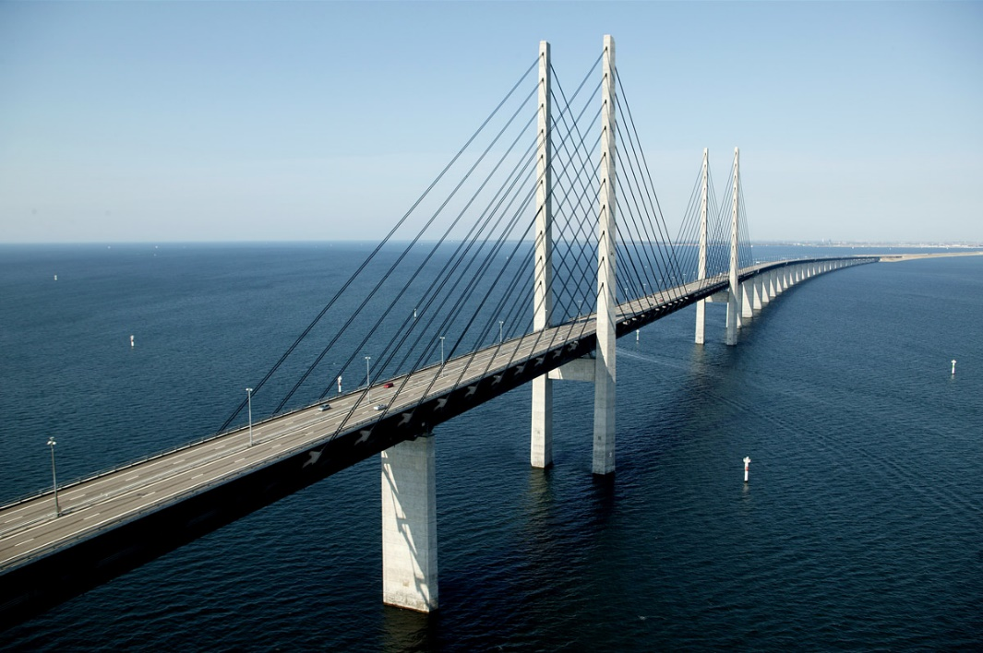

|  |  |  |  |  |
| --- | --- | --- | --- | --- |
| **Section** | **Question** | **Answer** | **Marks** | **Notes** |
| 1 | 1 | -2, -4 | M1  A1 | (x ± 2)(x ± 4) |
|  | 2 | y = 3 or y = 4 cao  x = ± $\sqrt{3}$ or x = ± 2 cao | M1  A1  B2 | For (y-3)(y+4) oe eg use of quad form  y = 3 or y = 4 cao  B1 for two roots correct or ft ‘their’ y  B2 for cao |
|  | 3(i) | (x – 3)2 - 7 | B1  M1A1 | (x – 3)2  -7 |
|  | 3(ii) | (3,-7) | B1 | ft from part (i) |
|  |  |  |  |  |
| 2 | 1 | v = $\sqrt{\frac{2E}{m}}$ cao www | B3 | Award M1 for a correct first constructive  step, M2 for v2 = oe |
|  | 2 | r = | B3 | Award M2 for r3 = , M1 for cube root  of ‘their’ r3 |
|  | 3 | C = oe | M1  M1  M1  A1 | PC + 4P = C  4P = C – PC  4P = C(1 – P) |
|  |  |  |  |  |
| 3 | 1 | (0.3,1.9) | M1  A1A1 | for substitution or for rearrangement  one mark each coordinate |
|  | 2 | ( $\frac{10}{3},\frac{5}{3})$ | M1  A1A1 | for substitution or for rearrangement  one mark each coordinate  Note: award B2 if roiunded to 1dp or worse |
|  | 3 | ( $\frac{2}{5}, \frac{11}{5})$ or (-1,-2) or answer given as x=, y= | M1  M1  A1A1 | substituting linear into non-linear  forming quadratic in x  one mark for each set of solutions |
|  |  |  |  |  |
| 4 | 1(i) | 7 | M1  A1 | 9-2 |
|  | 1(ii) | $\frac{5}{7}$ + $\frac{4}{7}$ $\sqrt{2}$ | M1  M1  A1 | multiplying top and bottom by 3 + $\sqrt{2}$ $\frac{3+2+3\sqrt{2}+ √2}{7}$ if one (or none) error only |
|  | 2(i) | 30√2 | M1  A1 | for √8 = 2√2 or √50 = 5√2 |
|  | 2(ii) | $\frac{1}{11}$ + $\frac{2}{11}$ $\sqrt{3}$ | M1  M1  A1 | multiplying top and bottom by 6 + $\sqrt{3}$ denominator = 11 (or 33) |
|  |  |  |  |  |

|  |  |  |  |  |
| --- | --- | --- | --- | --- |
| 5 | 1(i) | 1 | B1 |  |
|  | 1(ii) | a8 | B1 |  |
|  | 1(iii) |  | B1  B1  B1 | 3b  a3  inverse |
|  | 2(i) | ±5 | M1  A1 | for or seen |
|  | 2(ii) | 8x10y13z4  (or 23x10y13z4) | B3 | B2 for 3 elements correct  B1 for 2 elements correct |
|  |  |  |  |  |
| 6 | 1(i) | Grad AB = 1  Grad BC = -1  product of gradients = -1 hence perp | M1  M1  C1 |  |
|  | 1(ii) | 10 | M1  A1 | Use of pythagoras |
|  | 2 | y = -4x + 19 cao  Midpoint (4,3)  verifying on line x + 2y = 10 | M1  M1  A1  B1  C1 | calculating m  using (y -7) = m(x-3) |
|  |  |  |  |  |
| 7 | 1 | Cubic the correct way up  -1, 2 and 5 indicated on x-axis  10 indicated on y-axis | G1  G1  G1 |  |
|  | 2 | Negative quadratic curve  Intercept (0,9)  Through (3,0) and (-3,0) | G1  G1  G1 |  |
|  | 3 | Any correct y value calculated  (0,5), (1,1), (2,-1), (3,-1), (4,1) and (5,5) calculated  Above points plotted  Smooth parabola through the points | B1  B1  G1  G1 |  |
|  |  |  |  |  |
| 8 | 1 | y = (x – 2)2 - 4 | B2 | M1 if y omitted, or for y = (x + 2)2 - 4 |
|  | 2(i) | Translation of  ($\begin{matrix}2 \\ 0\end{matrix}$) | B1  B1 |  |
|  | 2(ii) | y = f(x – 2) | B2 | B1 for y = f(x + 2) |
|  | 3(i) | Translation of  ($\begin{matrix}-4 \\ 0\end{matrix}$) | B1  B1 |  |
|  | 3(ii) | sketch of parabola right way up  min at (0,-4) and graph through (-2,0) and (2,0) | B1  B1 |  |
|  |  |  |  |  |

|  |  |  |  |  |
| --- | --- | --- | --- | --- |
| 9 | 1(i) | 15.5 | M1  A1 | Use of Pythagoras |
|  | 1(ii) | x = 75.5° | M1  A1 | (cos x = $\frac{4}{16}$) correct ratio and substitution |
|  | 2 | √8 or 2√2 (but not ± √8) | M1  M1  A1 | Use iof pythagoras  use of tan Ɵ = opp / adj |
|  | 3 | Smooth curve between y = 1 and y = -1  (90,0) and (270,0)  (0,1), (180,-1), (360,1) | G1  G1  G1 |  |
|  |  |  |  |  |
| 10 | 1(i) | 9.0 or 8.96 or 8.960 | M1  M1  A1 | for use of cosine rule  for square-rooting ‘their’ 80.2(8) |
|  | 1(ii) | 13.3 or better (13.2577..) | M1  A1  A1 | use of ‘their’ 0.5 x 4.1 x 6.6 x sin 108  correct values  ans |
|  | 2 | BC = 384 (or better)  Total length = 1034m  (or better) | M1  M1  A1  A1 | recognisable attempt at cosine rule  BC2 = 3482 + 3022 – 2x348x302xcos72  BC = 383.86…..  Total length = BC + 650 ft |
|  |  |  |  |  |