**A Level Film Studies- summer transition work**

During the A Level Film Studies course we study a selection of short films from the following list:

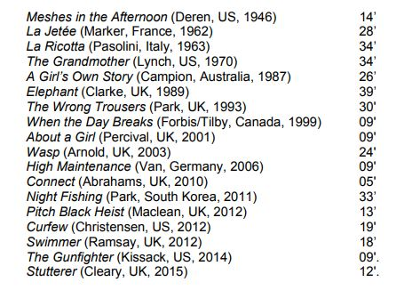

All these films (except 1- The Stutterer) can be found on our blog site:

<http://heathenmedia.co.uk/filmc3production/>

Choose 3 of the above films to watch carefully. For each one, complete the analysis grid attached. I will ask you to feedback on ONE of your chosen films in September.

Transition work: short film analysis sheet

Which short film did you watch?

………………………………………………………………………………………………………………………………

Part 1. Brief reference

|  |  |
| --- | --- |
| What did you like about the film? | What didn’t you like? |

Part 2: Analysis of narrative

|  |  |
| --- | --- |
| **Narrative**  **Feature** | **Example** |
| **Establishing protagonist (main character)**   * What information do we find out? How is it conveyed? * How do the key elements of film form help to create meaning? |  |
| **Establishing other characters**   * What information do we find out? How is it conveyed? * How do the key elements of film form help to create meaning? |  |
| **Establishing**  **Location (time and place)-** what information do we find out? How is it conveyed?  - How do the key elements of film form help to create meaning? |  |