Yr 12 Language Summer Assignments

1. Read the following story carefully and then underline the following language features:

* Nouns
* Verbs
* Adjectives
* Adverbs
* Pronouns
* A simple sentence
* A complex sentence

If you are unsure what any of these features are, then you need to research them, because you should be familiar with these concepts before you start the course!

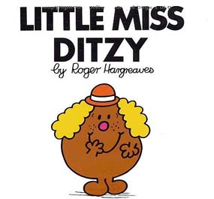

Little Miss Ditzy didn’t set the alarm on her phone because she had a ‘free’ first period. She woke up at 9.45 and by the time she strolled into school she was ten minutes late for Period 2. When Little Miss Ditzy sat down she put her phone on the desk. The miserable old teacher told her to put it away. This was against Little Miss Ditzy’s human rights, so she kept it on her lap in case she received a vital message.

Little Miss Ditzy had unfortunately forgotten to bring all of the notes from last lesson, and the work she had done was on loose paper at the bottom of her bag. When Little Miss Ditzy pulled it out, it was very crumpled and her Coke had leaked over most of it. Poor Little Miss Ditzy.

Little Miss Ditzy kept up this lackadaisical approach to her studies for two years. Little Miss Ditzy massively underachieved and didn’t get any offers from universities. Silly Little Miss Ditzy!

1. Many different factors go into how we personally use language, including: **gender, ethnicity, social class, region, age** and **interests**. There is debate about which factors are most important.

Write an essay, entitled **My Language Life**, in which you evaluate which of these factors affects the way you communicate and how you use language differently in different circumstances.

Things to consider as well as the factors:

* Do you use language differently at home than at school?
* Do you have a job? If so, how do you need to speak there?
* Does the way you communicate on social media differ from how you communicate face to face?
* Do you speak differently with different members of the family?