Careers
Careers Events this Term
- 270318 – Y12 Oxbridge Trip
- 280318 – Y8 Cultivate a Business Idea Programme A20 P2

PATHWAYS TO LAW KS4 EVENT: ‘The Trial’
Oxford University is continuing to recruit students from local schools to attend a special Pathways to Law event for KS4 students. The programme is a two-day event aimed at Year 10 and Year 11 students on the 27th and 28th April, 2018. Pathways to Law was set up in 2006 by the Sutton Trust and the College of Law (now the Legal Education Foundation) to widen access to the legal profession.
In addition to the event itself, further opportunities through the University of Oxford’s Faculty of Law and its partners may be made available to participants following the event. This includes a one-day work experience with Maitland Chambers as prizes for outstanding effort and achievement on the day!

They are looking to invite 30 students to ‘The Trial’, which will be held at the St Cross Building in Oxford and take place across 2 days:
Session 1: Friday 27 April, 16:30 – 18:30
Session 2: Saturday 28 April, 09:45 – 16:30
Students applying should be available and able to attend both sessions in full. Places are open to all KS4 students attending targeted state schools in Oxfordshire, Buckinghamshire, Berkshire and Swindon with an interest in studying law. Priority may be given to applicants who meet the University’s widening access and participation criteria. This includes:
- ACORN and POLAR3 postcode data. Please visit http://acorn.caci.co.uk/what-is-acorn and http://www.hefce.ac.uk/analysis/yp/POLAR/ for more information.
- History of limited progression to higher education within families.
Applications are open now and close on 15 April 2017. The online application form is being hosted by the Widening Access and Participation team and can be accessed at: www.uniq.ox.ac.uk/p2lapply

The programme, organised and run by Oxford University’s Law Faculty in partnership with Maitland Chambers, is a two-day event designed to introduce aspects of Law to interested KS4 students. On the first day, students will ‘witness’ a staged crime, followed by academic sessions on related law and concepts. On the second day, students will receive training on advocacy and how courts work from Maitland Chambers’ barristers. They will then be given a role to play in a mock trial with the assistance of barristers and student ambassadors, and certificates and prizes will be handed out at the end of the day. The event is completely free of charge to students and assistance with travel costs is available on request. For further information please contact pathwaystolaw@admin.ox.ac.uk. More urgent queries about applying and the application system may be directed to Charlotte on 01865 280 198, and about the programme to Julia on 01865 618077.
Y10 & Y11 ESSAY COMPETITION
IChemE’s Thames Valley members Group is again running its hugely popular essay competition. The theme for 2018 is “Life without Plastic”, considering the technological advances for plastic production as well as plastic alternatives. I have attached details of this competition, the closing date for all entries is 31 May 2018. The winner will receive £100 Amazon voucher!
Please email me your entries and I will collate and forward on – Good Luck!

MICROSOFT APPRENTICESHIP OPEN EVENING
Wednesday 28 March 2018 (4pm-8pm)
At the open evening students and parents will have the opportunity to meet current and former apprentices, hiring managers and the recruitment team, as well as their education providers. There will also be an opportunity to tour the campus and get hands on experience with some of the latest technology. If you would like to attend please register at: aka.ms/insightevening or contact them at: apprentriceevent@microsodft.com

NETWORK RAIL ADVANCED APPRENTICESHIP SCHEME
Network Rail are recruiting now for September 2018 start. The deadline for applications is Monday 2 April 2018. They are seeking people who will be 18 or over on or before 29 September 2018- there is no upper age limit. They are asking for applicants to have at least 4 A*-C GCSEs which must include English, Maths and Science (or Engineering). For detailed information on their opportunities please take time to look at:
www.networkrail.co.uk/careers/apprenticeships/apply

SSE ENGINEERING CRAFT APPRENTICESHIPS & TRAINEE ENGINEER PROGRAMME
SSE have extended their deadline for applications to Sunday 1st April. They currently have vacancies in Berkshire: Slough, Thatcham & Theale depots. To find out more information please visit: www.sse.com/careers

PRUDENTIAL RECRUITING
Prudential have current vacancies within their Reading Office. Please see the links below for the posts available. Please be advised the closing dates for applications is 4th April 2018. They are looking for enthusiastic, professional, hardworking individuals who are willing to learn and determined to succeed.

Candidates must be 16 years or older with a minimum of 5 GCSEs grades A - C including Maths and English. Apprentices will follow 13-15 months Advanced Apprenticeship framework (Level 3) in Business Administration or in Finance/Accountancy
www.pru.co.uk/apprenticeships / http://prudential.bppuniversity.ac.uk
For any queries please contact: apprenticeship@prudential.co.uk

STUDENT LADDER
www.studentladder.co.uk is an online resource that provides information and guidance from GCSE through to graduation. Their database includes very useful information all in one place! They have information on:
- 100’s of advanced, higher and degree apprenticeships
- Work experience placements
- Gap Year Placements – paid placement prior to university
- Oxbridge Applications
- University and degree guidance
- Career insights
- Application advice
In addition the site also offers students information throughout their university journey, providing over 2,500 internships, industrial placements and graduate roles.

Mrs Eileen Wooller
Careers Officer
ewooller@littleheath.org.uk

Job Spotlight
BP: What's your best piece of careers advice?

To mark International Women’s Day, BP Magazine asks staff from around the globe – at all levels of the business – what’s the best piece of careers advice they’ve ever been given and why
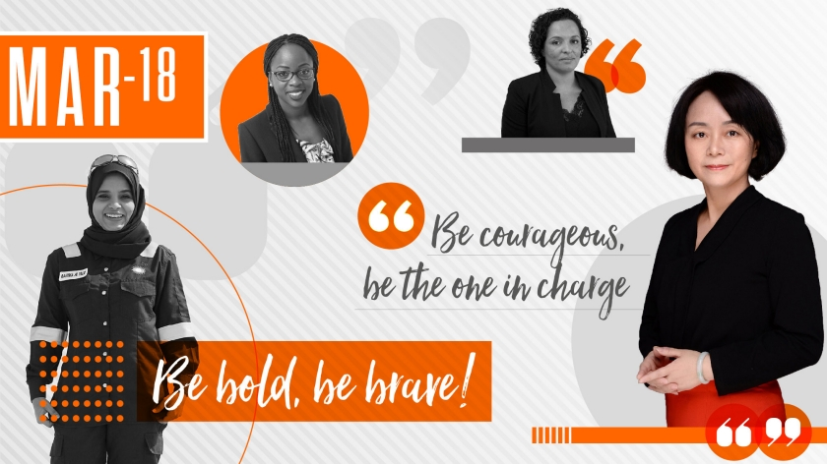

Aleida Rios, US
Vice president for operations, Gulf of Mexico

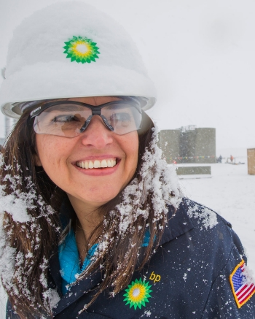
“Go for it, do not be afraid. Be bold, be brave! I was being offered an operations manager position when I was eight months pregnant and thinking ‘this is too hard, I am leaving’. I stayed because of the confidence my mentor gave me. It’s important that we mentor, support and promote women in STEM - #PressForProgress!”
Aleida has worked at BP for 26 years, joining after four summers as an intern with the business while in college. With a degree in chemical engineering, she started out in the oil fields of West Texas. Today, she is responsible for operations on BP’s four offshore platforms in the Gulf of Mexico.
A mother of three teenagers and advocate for diversity in the workplace, Aleida was named one of Fortune magazine’s 50 most powerful Latinas in 2017.

Rahima Al Talai, Oman
Completions engineer, Wells
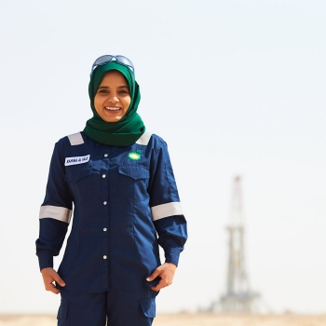
“Development and success require accepting challenges and turning them into opportunities. You’ll push your own limits and show your potential when you face challenges – and if you don’t always succeed, there’ll be a lesson learned instead. You’ll never know until you try something new and it’s ok to be the first one to do so."
Rahima's career at BP began six years ago, after studying petroleum and natural gas engineering at Oman’s Sultan Qaboos University. She was the first female Challenger (BP’s high-potential graduate programme) to join the wells completion team in Oman and spent her first year in the North American Gas business. “I feel privileged to have had these experiences that I’m able to share with upcoming engineers,” she says.

Yosi Yuliani, Indonesia
Laboratory team supervisor, Petrochemicals
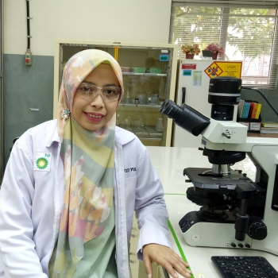
“Don’t wait until someone knocks on your door. Be active and put yourself out there. Be visible and easy to contact. Use every job as an opportunity to learn something new and keep an open mind, never stop learning, even if that means failing occasionally.”
In her role, Yosi manages a team of nine. She says: “When I started out as a junior in the BP Merak laboratory, I never imagined I’d one day be the supervisor in an all-male environment and leading those more senior colleagues.
"I’ve worked closely with the team to foster trust and respect, adapted to my new working environment and, together, we’ve won awards both internal and external.”
Chan Boodhai, Trinidad
Executive assistant to BP’s chief executive for Upstream
“Do the best job that you can, regardless of how big or small the task is. The quality of your work represents who you are - every time.
And, genuinely try to make a difference - care for your colleagues and help them to be their best! I try to be very conscious of this and apply it to what I do every day.”
Chan is a chemical and process engineer from Trinidad and Tobago and has worked for BP for 13 years. She has spent most of her career in the Global Operations Organization and took on her current role a year ago.
She says: “My job is awesome – it is high pace and I am learning so much about our business strategy.
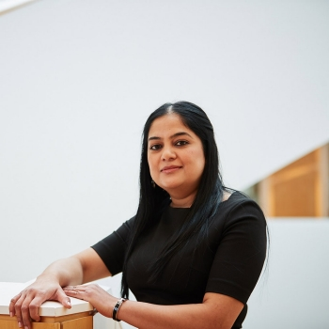
"Adding that business knowledge to my technical skills has opened my eyes to new ways of working and varied things to consider when making decisions. Bernard [Looney] spends a lot of time mentoring and coaching me, which I appreciate.”
Dr. Cynthia Pierre, US
Inspection, materials, corrosion and engineering superintendent, Cherry Point refinery
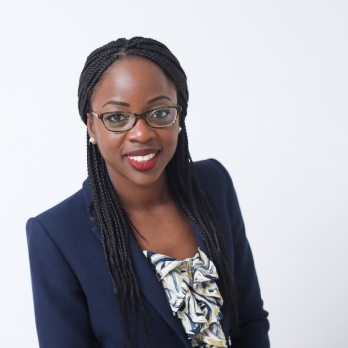
“‘It's not who you know, it's who knows you and your work.’ To me, this advice highlights the importance of proactively building a network and keeping those individuals informed of your contributions and impact.
The other piece of advice that resonates is ‘take care of yourself first’, because that will influence your ability to be successful.”
After spending two-and-a-half years working in Australia at Kwinana refinery and completing BP’s Future Leader Programme in 2017, Cynthia now leads a team of 16 inspectors and engineers at the Cherry Point refinery in Washington.
Leigh-Ann Russell, UK
Vice president for global wells
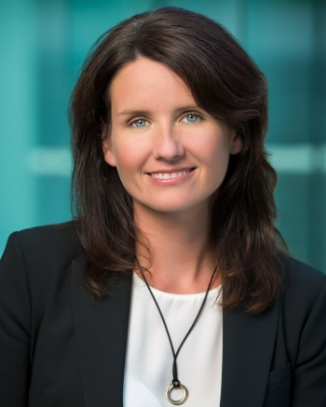
“At one point in my career I was struggling with role choices. My mentor gave me the best advice. He said, ‘don’t worry too much about external factors, just come to work every day and try to make a difference’.
If you come to work with this attitude, you will get so much more out of your career. Performance is the most important differentiator.”
A mechanical engineer by degree, Leigh-Ann joined BP in 2005 after working for other companies in the industry. Today she leads the central technical and business function for BP’s wells organization. She says: “I love how my very diverse, global team comes together to help BP drill some of the world’s most challenging wells, safely and successfully.”

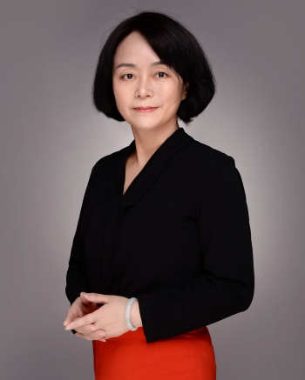
Song Mei (May) Zheng, China
Head of shareholder office, acetyls and aromatics in Asia
“Discover your aspirations while you’re young and follow them. Be courageous, be the one in charge and make things happen. It's fine to make mistakes as long as you’re moving forward and continuing to grow.”
A chemical engineer by background, May joined BP Zhuhai in 2001 and pursued a mixture of learning and technical roles, before transferring to the UK as a senior business auditor. Back in China, she is now the head of the shareholder office for Asia’s acetyls and aromatics business. A single mother with a grown-up daughter, she learns boxing in her spare time. She says: “In China, we have a saying that translates as ‘women can hold half of the sky’ – it’s a great way to think about equality.”
Özlem Sakarya, Turkey
Analytical laboratory leader, Global Fuels Technology Centre, Bochum
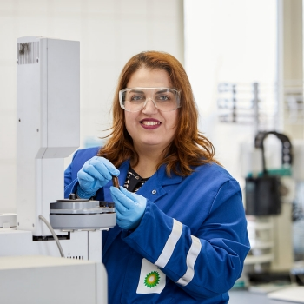
“Showing potential and the ability to adapt – and grow – into increasingly complex roles is as important as successful performance in your current job.
I moved from a refinery role in Turkey to lubricants product development in Germany with no German language knowledge or prior experience in that part of the business. Nobody has all the requirements for a new job at first – therefore be brave, apply for challenging roles even if you don't think you tick all the boxes.”
Özlem has a master's in chemistry and a minor degree in metallurgical engineering and material science. A graduate from BP’s Emerging Leader programme as well, she has more than 17 years’ experience in downstream businesses.

Now, she is head of the global fuels technology analytical laboratory in Bochum. Of her job, the mum-of-two and green belt in judo says: “One of the things I enjoy most is helping my team to improve, and also understand how they fit into the bigger BP picture and how what they do is really meaningful.”
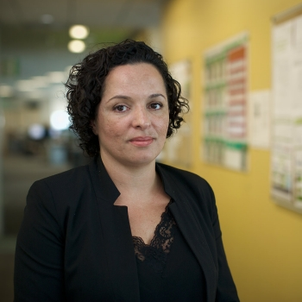
Tania Silva, Angola
Area planning and commercial operations manager, Block 31
“It’s easy to be overwhelmed in your early career with new challenges. There’s a tendency to always think ‘what’s my next role?’ But, a conversation with my mentor made me consider things differently. He said: ‘Imagine yourself in 20 years’ time. Where do you see yourself? Then, start building a timeline back from that point to today.’
The challenge is to consider all the professional, geographical and personal variants that may impact your choice. Once the big picture is clear, making career decisions becomes easier.”
Tania is responsible for stakeholder management on behalf of BP in Angola’s Block 31 joint venture – an offshore area that includes the four-field Plutão, Saturno, Vénus and Marte (PSVM) development.
A graduate in commerce and business management, with more than 14 years’ experience in BP, she now works with three other partners with an interest in the block. She says: “The best thing about my role is the overall visibility I have across the entire offshore asset, while the challenge and reward is building and maintaining great relationships.”

