**The experience machine**

**Hedonism** is a school of thought that argues that pleasure and happiness are the primary or most important intrinsic goods and the proper aim of human life. A hedonist strives to maximize net pleasure (pleasure minus pain).

Ethical hedonism is the idea that all people have the right to do everything in their power to achieve the greatest amount of pleasure possible to them. It is also the idea that every person's pleasure should far surpass their amount of pain. Ethical hedonism is said to have been started by Aristippus of Cyrene, a student of Socrates. He held the idea that pleasure is the highest good.

**The thought experiment**

Nozick asks us to imagine a machine that could give us whatever desirable or pleasurable experiences we could want. Psychologists have figured out a way to stimulate a person's brain to induce pleasurable experiences that the subject could not distinguish from those he would have apart from the machine. He then asks, if given the choice, would we prefer the machine to real life?

Nozick also believes that if pleasure were the only intrinsic value, people would have an overriding reason to be hooked up to an "experience machine," which would produce favorable sensations.

**Initial concerns**

Who would run the machines if everyone plugs in? Nozick asks us to ignore this concern, since it does not adversely affect the thought experiment. One could simply stipulate that the machines have been so well designed as to be fail-proof.

The experiment is also open to multiple interpretations. For instance, Nozick claims that you could either map out the rest of your life in the machine before plugging in, or you could unplug periodically to choose your programming for the next cycle. While interesting, these variations do not directly affect the argument.

**The argument**

The argument is along these lines:

* P1: If experiencing as much pleasure as we can is all that matters to us, then if we will experience more pleasure by doing x than by doing y, we have no reason not to do x rather than y.
* P2: We will experience more pleasure if we plug into the experience machine than if we do not plug into the experience machine.
* C1: If all that matters to us is that we experience as much pleasure as we can then we have no reason not to plug into the experience machine. (P1&P2)
* P3: We have reason not to plug into the experience machine.
* C2: Experiencing as much pleasure as we can is not all that matters to us. (C1&P3, by MT)

**Reasons not to plug in**

Nozick provides us with three reasons not to plug into the machine.

1. *We want to* do *certain things, and not just have the experience of doing them.*
   * "It is only because we first want to do the actions that we want the experiences of doing them." (Nozick, 43)
2. *We want to* be *a certain sort of person.*
   * "Someone floating in a tank is an indeterminate blob." (Nozick, 43)
3. *Plugging into an experience machine limits us to a man-made reality (it limits us to what we can make).*
   * "There is no *actual* contact with any deeper reality, though the experience of it can be simulated." (Nozick, 43)

**Conclusion**

Nozick is using this thought experiment to illustrate his claim against Hedonism. It raises the question of what matters other than experiences, by making readers realize that they wouldn't plug into the experience machine even if they could. This raises the question of why only felt experiences dictate what can and cannot be done to an animal.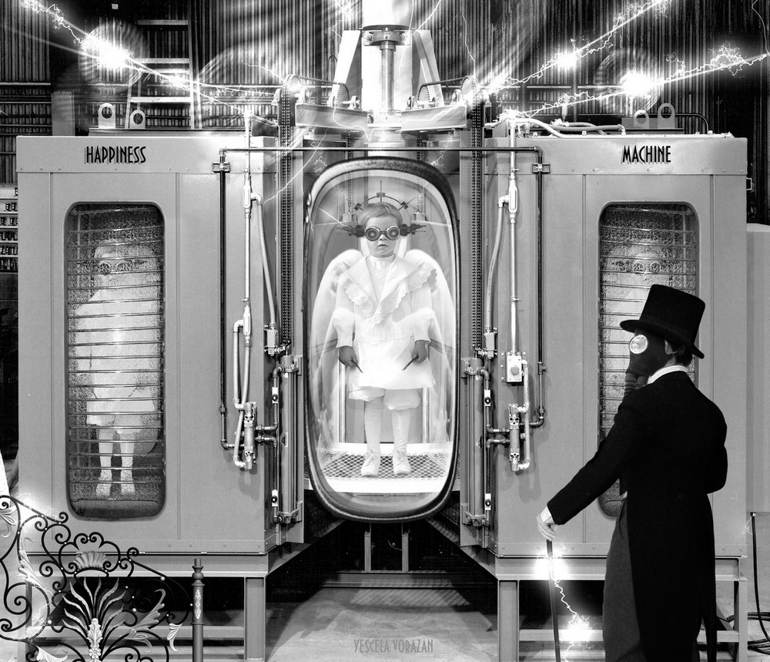

**The trolley problem**

The **trolley problem** is a thought experiment in ethics. The general form of the problem is this: There is a runaway trolley barreling down the railway tracks. Ahead, on the tracks, there are five people tied up and unable to move. The trolley is headed straight for them. You are standing some distance off in the train yard, next to a lever. If you pull this lever, the trolley will switch to a different set of tracks. However, you notice that there is one person on the side track. You have two options: (1) Do nothing, and the trolley kills the five people on the main track. (2) Pull the lever, diverting the trolley onto the side track where it will kill one person. Which is the most ethical choice?

Is it better to murder one person or allow five to die?

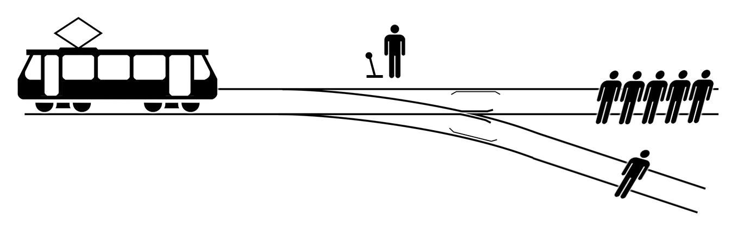

**Difference in perception**

In the Dream argument, Descartes argues that he often dreams of things that seem real to him while he is asleep. In one dream, he sits by a fire in his room, and it seems he can feel the warmth of the fire, just as he feels it in his waking life, even though there is no fire. The fact that he feels the fire doesn’t really allow him to tell when he is awake and when he is dreaming. Moreover, if his senses can convey to him the heat of the fire when he does not really feel it, he can’t trust that the fire exists when he feels it in his waking life.

[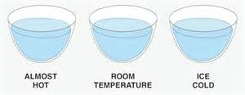](http://www.bing.com/images/search?q=hot+and+cold+water+experiment+philosophy&view=detailv2&adlt=strict&id=D0A3E6C2845448CE6DC0BE57A1A692B7ADFF3878&selectedIndex=24&ccid=UgPwGVra&simid=608042339543747739&thid=OIP.M5203f0195adaff0994cad0c5dbe1bdc4o0)

**Colour perception and delusion**

[](http://www.bing.com/images/search?q=seeing+same+colour+different&view=detailv2&adlt=strict&id=2DAEE6D6CBC6BF06F4A829419F0E7276C7F811E0&selectedIndex=16&ccid=IRLfejCK&simid=608033371660683862&thid=OIP.M2112df7a308abee29b422373381e515co0)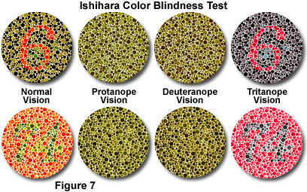

In the Dream argument, Descartes argues that he often dreams of things that seem real to him while he is asleep. In one dream, he sits by a fire in his room, and it seems he can feel the warmth of the fire, just as he feels it in his waking life, even though there is no fire. The fact that he feels the fire doesn’t really allow him to tell when he is awake and when he is dreaming. Moreover, if his senses can convey to him the heat of the fire when he does not really feel it, he can’t trust that the fire exists when he feels it in his waking life.

# **The Brain in a Vat Argument**

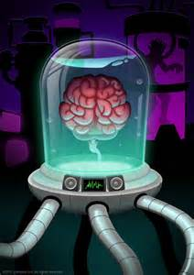The Brain in a Vat thought-experiment is most commonly used to illustrate global or Cartesian skepticism. You are told to imagine the possibility that at this very moment you are actually a brain hooked up to a sophisticated computer program that can perfectly simulate experiences of the outside world. Here is the skeptical argument. If you cannot now be sure that you are not a brain in a vat, then you cannot rule out the possibility that all of your beliefs about the external world are false. Or, to put it in terms of knowledge claims, we can construct the following skeptical argument. Let “P” stand for any belief or claim about the external world, say, that snow is white.

1. If I know that P, then I know that I am not a brain in a vat
2. I do not know that I am not a brain in a vat
3. Thus, I do not know that P.

The Brain in a Vat Argument is usually taken to be a modern version of René Descartes' argument (in the Meditations on First Philosophy) that centers on the possibility of an evil demon who systematically deceives us. The hypothesis has been the premise behind the movie The Matrix, in which the entire human race has been placed into giant vats and fed a virtual reality at the hands of malignant artificial intelligence (our own creations, of course).