**Unifrog – Student Log Ins**

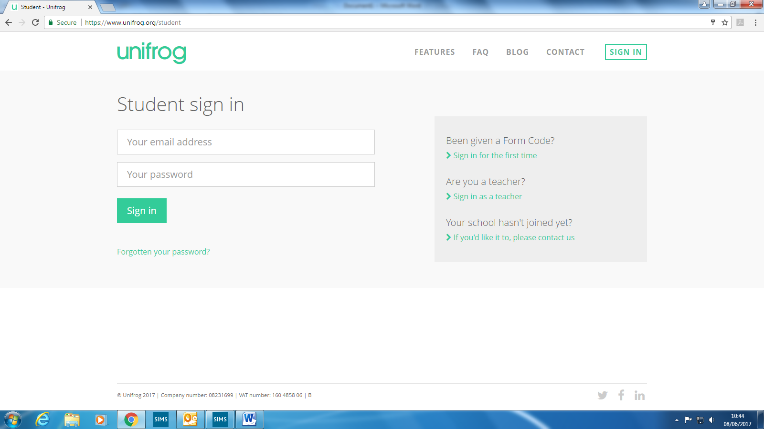To log in, you need to click on the sign in for the first time:

Put in your form code (tutor code) and all your personal details. Use an email address that you use regularly.

The form codes are:

|  |
| --- |
| cholittle18 |
| isclittle18 |
| jfilittle18 |
| vtolittle18 |
| ewnlittle18 |
| cdclittle18 |
| tsclittle18 |
| pwalittle18 |
| sbelittle18 |
| cjolittle18 |

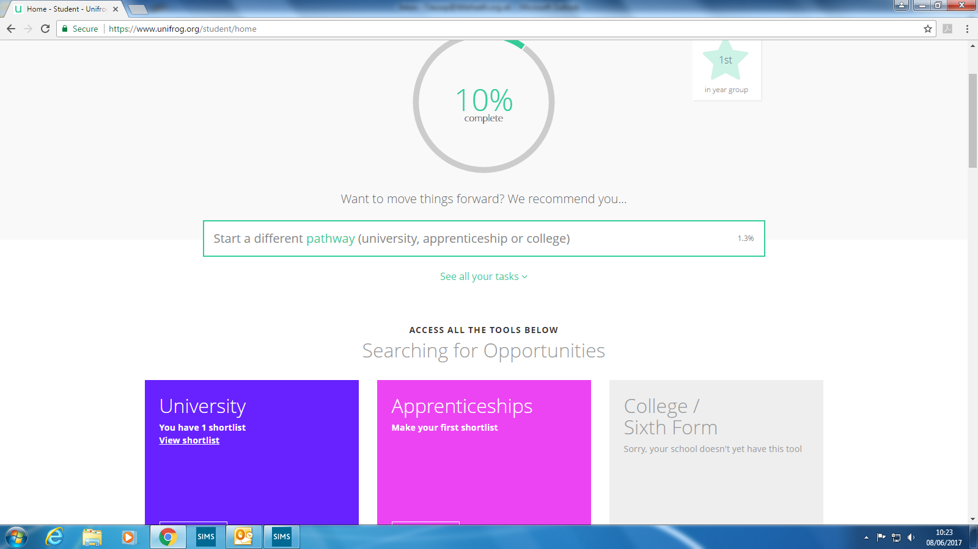This is what you will see when you log in:

**Searching for opportunities:**

This is where you can use the University search tool, or the apprenticeship search tool. For those interested as well, you can use the Oxbridge tool.

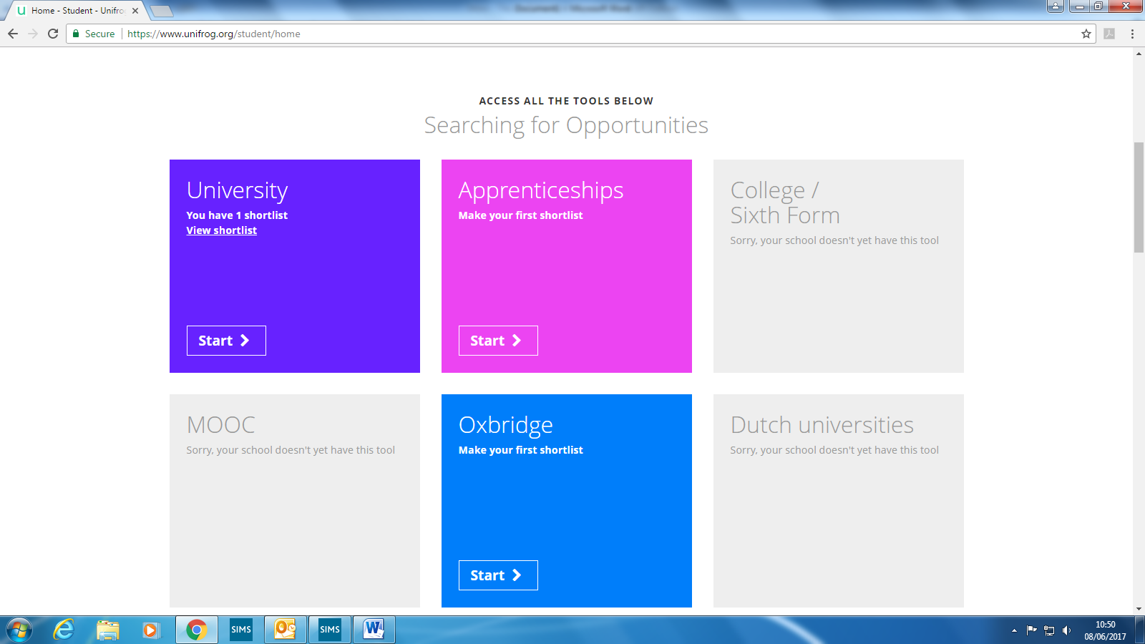

**Making Applications:**

On Unifrog there are now excellent tools to help you bring together all your skills and qualifications into one place, which means it makes it a lot easier to complete application forms, as you just need to log into Unifrog to get the information.

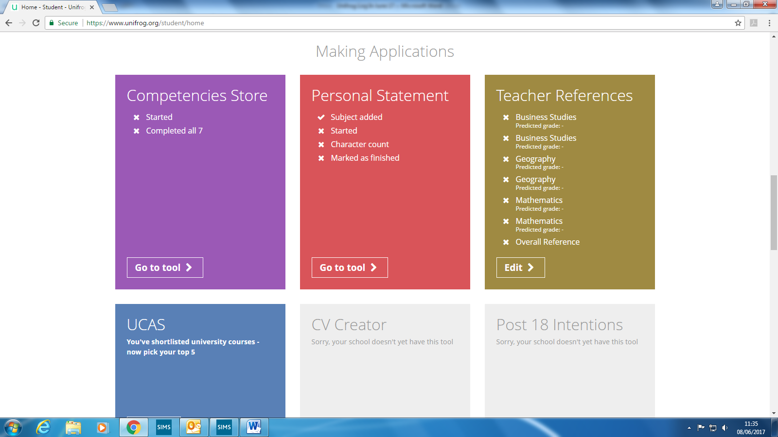

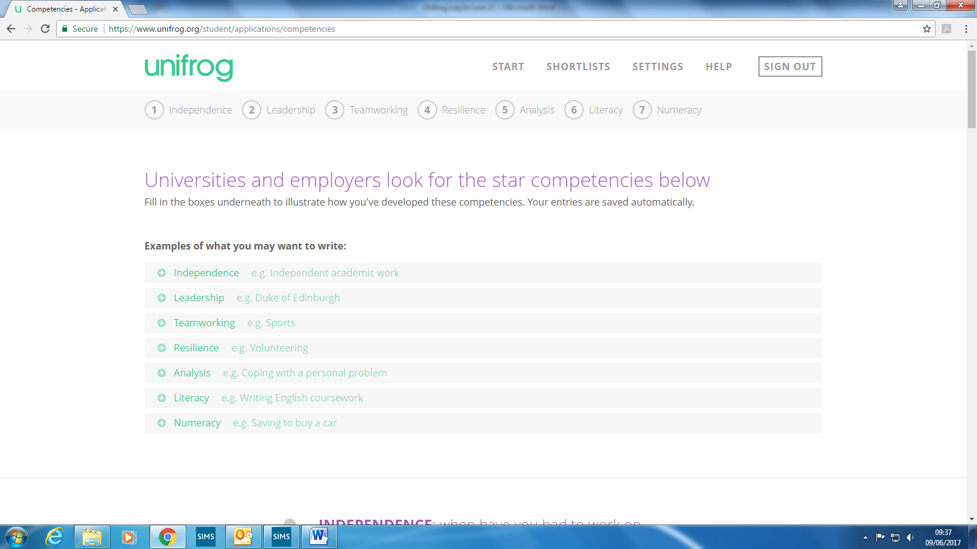**Competencies Store:**

This section of Unifrog allows you to put down all of your skills and qualities that you can then use to reflect on when completing an application. It is a very good starting point to help you create a personal statement or to help you answer questions on application forms. All you need to do is to scroll down, pick the relevant skill and write up your evidence of what you have completed. This will help you layout what skills you have and what you can work on, if there are any gaps in this.

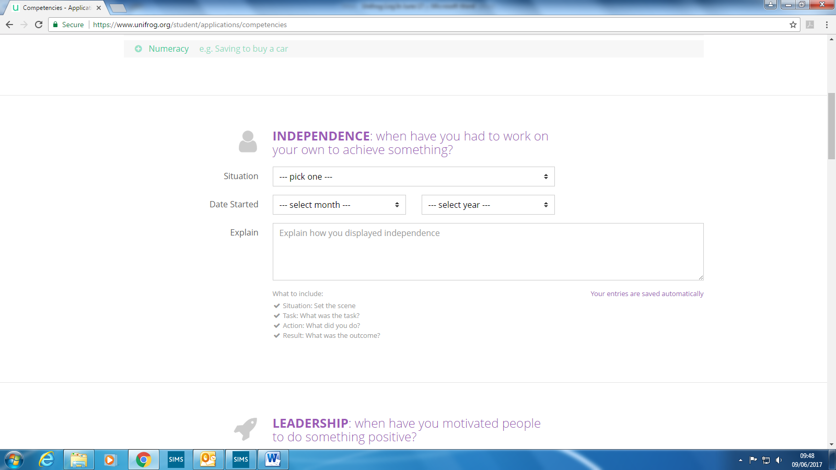

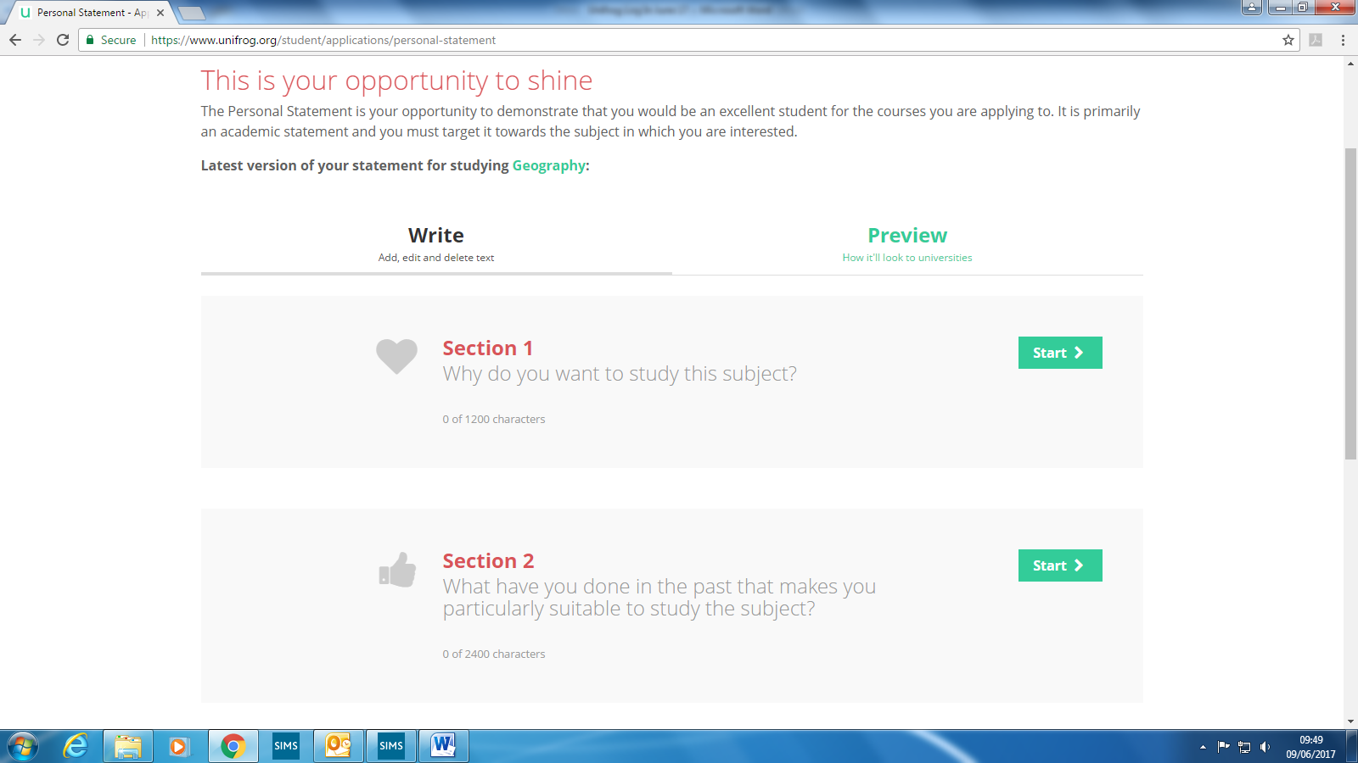**Personal Statement Tool:**

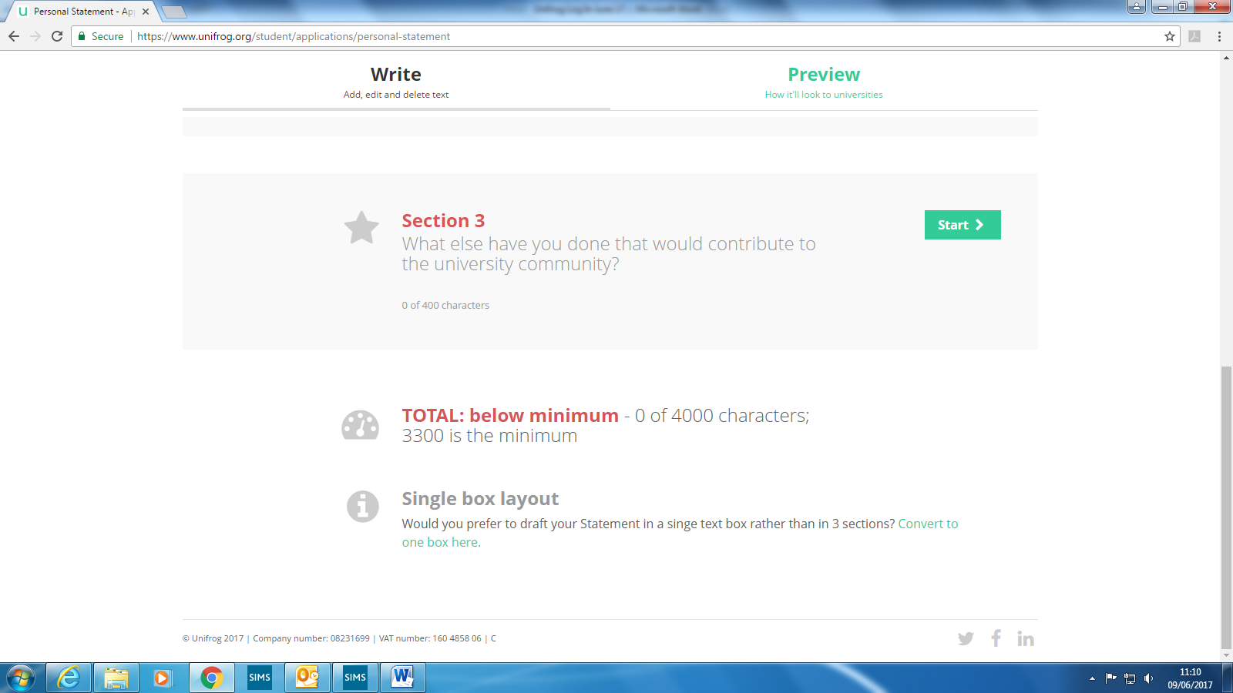This allows you to draft out your personal statement, you can either write it in one go or use the style above to split it into each section. Use the Unifrog guide and the help sheets that you will be given on Futures Day to help you write your personal statement. Your mentor will then be able to look, comment and advise on how best to restructure it on Unifrog, so you can then make an improved draft. It may take several drafts to get it right, but each time it should be an improvement on the last version. If you would like the single box layout then click here (bottom of the screen).

**Teacher References:**

Your teachers will write your subject references on Unifrog, therefore you need to put in all of their information into your account. Simply put in your subjects and your teachers. (Do not do this until you’re in year 13 as your teachers may change)

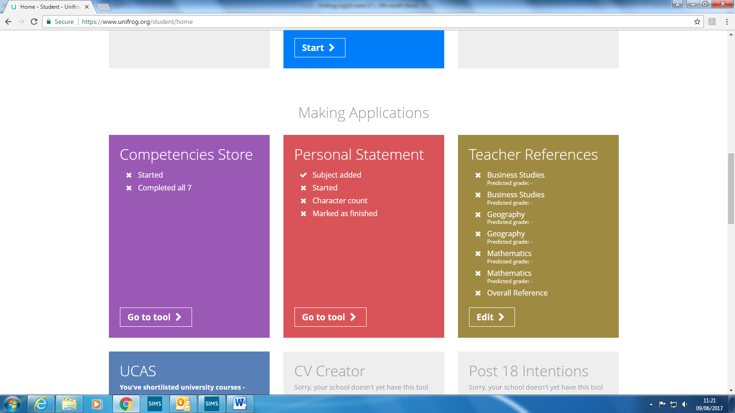

**Top Tips:**

When searching for apprenticeship/university:

* The area to select is "South East"
* If you do not know your post code use RG31 5TY
* Enter your personal mobile as this is the number employers/ universities will call
* When searching for apprenticeship/university use the "Filter" and "Rank" tabs to refine search e.g. by Wage, % coursework, distance from home, Russell Group etc

You can have as many searches as you like, so feel free to complete a search for more than one subject or one type of apprenticeship.

If you’re stuck then please do not hesitate to speak to Mr J or Mrs Wooller.