**Course text book and equipment list***[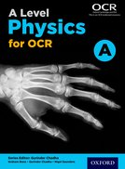](https://global.oup.com/education/product/9780198352181?region=uk)*

**The text book you will be using is** [A Level Physics A for OCR Student Book](https://global.oup.com/education/product/9780198352181?region=uk). ISBN 978-0-19-835218-1 Series Editor **Gurinder Chadha**, Author **Graham Bone**, and Author **Nigel Saunders. £42.00**

You will need to purchase this at the start of the year through the school as we may be able to get a slight discount on the full price. This excellent textbook covers both years of Physics and is used throughout the 2 year course.

**Equipment list:**

* Scientific calculator
* Pen
* Highlighters
* 30cm Ruler
* Pencils
* Sharpener