**The Bridge to A level**

**Test Yourself Mark Scheme**

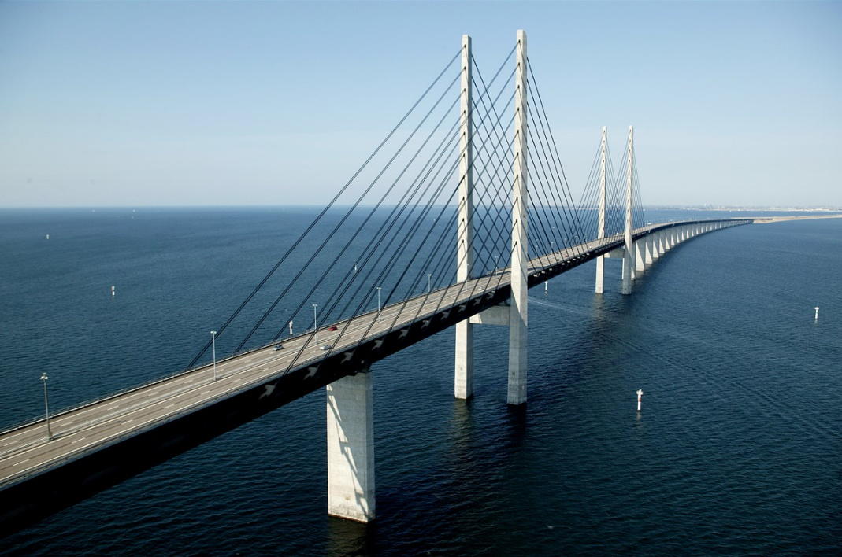

|  |  |  |  |  |
| --- | --- | --- | --- | --- |
| Section | Question | Answer | Marks | Notes |
| 1 | 1 | x = ± 3 | M2  M1  A1 | Use of quadratic formula (M1)  in x2 (M1)  x2 = 9  cao |
|  | 2(i) | 4 (x – 3)2 - 9 | B1  B1  M1A1 | a = 4  b = 3  c = -9 |
|  | 2(ii) | (3,-9) | B2 | B1 for each coordinate |
|  |  |  |  |  |
| 2 | 1 |  | B3 | B2 for t omitted  M1 for constructive first step  M1 for finding square root of their ‘t2’ |
|  | 2 |  | M1  M1  A1 | for 3x + mx = y + 5y oe  for x(3 + m) or ft sign error |
|  | 3 |  | M1  M1  M1  M1 | for multiplying by x-2  for expanding brackets  for cllecting x and ‘other’ terms  for factorising and dividing  Award all four marks only if fuly correct |
|  |  |  |  |  |
| 3 | 1 | x = $\frac{7}{11}$ y = $\frac{24}{11}$ oe www | B3 | B2 for one coordinate correct, or correct solution not erxpressed as coordinates  (or) M1 for substitution or elimination of one variable oe |
|  | 2 | a = 3  b = 32 | M1  A1A1 | Equating 5x – a and 2x + 18 and substituting x = 7 |
|  | 3 | x = -0.5 or 1  y = 4.25 or 2 | M1  M1  A1  A1 | for 7-3x = 2(x2 – 2x + 3) oe  for quadratic in x (2x2 – x – 1 = 0 oe)  x  y |
|  |  |  |  |  |
| 4 | 1(i) | $$3\sqrt{6}$$ | M1  A1 | for $\sqrt{4x6}$ oe seen |
|  | 1(ii) | 10 + $2\sqrt{7}$ | M1  M1  A1 | for attempt to multiply num and denom by 5 + $\sqrt{7}$ for 18 or 25 – 7 seen |
|  | 2(i) | $$28\sqrt{6}$$ | M1  A1 | for $30\sqrt{6}$ or $2\sqrt{6}$ oe |
|  | 2(ii) | 49 - 12 $\sqrt{5}$ | B2  B1 | for 49  for 12 $\sqrt{5}$ If B0, award M1 for 3 correct terms of 4 - 6 $\sqrt{5}$- 6 $\sqrt{5}$ + 45 |
|  |  |  |  |  |

|  |  |  |  |  |
| --- | --- | --- | --- | --- |
| 5 | 1(i) | 9 | M1  A1 | for 32 oe |
|  | 1(ii) | 8 (condone -8 or ±8) | M1  A1 | for 160.25 = 2 |
|  | 2(i) | 4x4y | M1  A1 | for two elements correct |
|  | 2(ii) | 32 | M1  A1 | for 25 oe |
|  | 3 |  | B1  B1 | numerator  denominator |
|  |  |  |  |  |
| 6 | 1 | Grad of AB = -3  Grad of BC = $\frac{1}{3}$ product of gradients = -1 | B1  B1 | either gradient  product of gradients need to equal -1 |
|  | 2 | (3,6) | B1 |  |
|  | 3 | Coordinates (0,2) (0.5,0) | M1  M1  A1A1 | for y = -4x + c  for y = -4x + 14  one mark for each set of coordinates |
|  | 4 | y = 3x - 7 | M1  M1  A1 | Gradient = 3  Subst in (4,5) into their ‘y = mx + c’ |
|  |  |  |  |  |
| 7 | 1 | Cubic the correct way up  x-axis cuts at -1, 2, 4 shown  y-axis cuts at 8 shown | G1  G1 G1 |  |
|  | 2 | Sketch of cubic correct way up  Curve through (0,0)  Curve touches x-axis at x=3 | G1  G1  G1 |  |
|  | 3 | Correct graph with clear asymptote at x = 2  (0, -0.5) shown | G2  G1 | (G1 for only one branch correct0 |
|  | 4 | 10 | B1 |  |
|  |  |  |  |  |
| 8 | 1 | y = x2 – 8x + 5 | B1 |  |
|  | 2 | f(x – 3) = (x – 3)3 –5(x – 3) + 2  (x2 – 6x + 9)(x – 3)  f(x – 3) = x3 – 3x2 – 6x2 + 18x + 9x – 27 – 5x + 15 + 2  = x3 – 9x2 + 22x - 10 | B1  B1  A1  B1 | Substitution  Partial expansion of cubic term  All correct unsimplified  Correct consolidation |
|  | 3 | f(x-4) = 2(x-4)3 + 7(x-4)2 – 7(x-4) – 12  2x3 – 17x2 + 33x | M1  M1  M1 | Substitution  Correct expansion of one pair of brackets  correct completion to given answer |
|  | 4 | (x + 1 – 3)(x – 2 – 3)(x – 4 – 3)  ie (x -2)(x – 5)(x – 7) | M1  A1 | Allow one slip  Oe |
|  |  |  |  |  |

|  |  |  |  |  |
| --- | --- | --- | --- | --- |
| 9 | 1 | Tan 42° = $\frac{opp}{adj}$ 0.9004 = $\frac{height of pole}{15}$ 13.5(06) m = height of pole | M1  M1  A1 |  |
|  | 2 | ± $\frac{\sqrt{13}}{4}$ | B3 | B2 for either - $\frac{\sqrt{13}}{4}$ or $\frac{\sqrt{13}}{4}$ or ± $\frac{\sqrt{13}}{\sqrt{16}}$ oe  or M1 for $\sqrt{13}$ seen |
|  | 3 | (0, 0)  ( 90, 1)  (270, -1)  (360, 0) | B1  B1  B1  B1 |  |
|  |  |  |  |  |
| 10 | 1(i) | C = 141.1…..  Bearing = 038. 8 (accept 038.9) | M1  M1  A1  A1 | Correct attempt at cosine rule  Correct full method for C  C  Bearing |
|  | 1(ii) | 3030 to 3050 acceptable | M1  A1 | Correct use of 0.5xaxbxsinC |
|  | 2 | AB = 7.80 (or better, 7.799…)  Area = 52.2 to 52.3 | M1  A1  M1  A1 | Correct use of sine rule  AB  2 x 0.5 x ’their AB’ x 11.4 x sin 36  Area |
|  |  |  |  |  |