**The Bridge to A level**

**Test yourself**

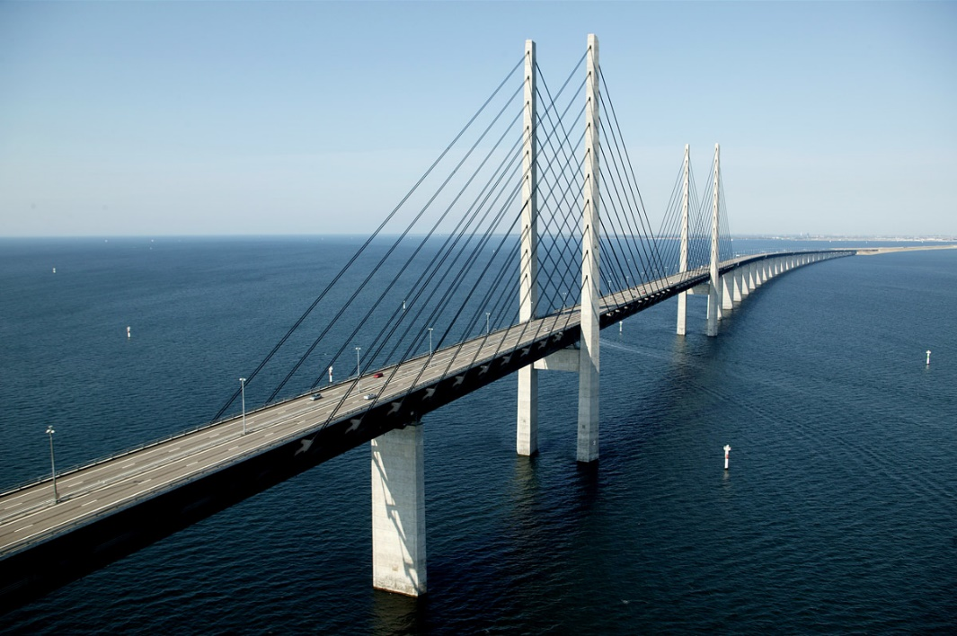

**1 Solving quadratic equations**

**Question 1**

Find the real roots of the equation x4 – 5x2 – 36 = 0 by considering it as a quadratic equation in x2

(4)

**Question 2**

(i) Write 4x2 - 24x + 27 in the form of a(x - b)2 + c

(4)

(ii) State the coordinates of the minimum point on the curve y = 4x2 - 24x + 27.

(2)

**Total / 10**

**2 Changing the Subject**

**Question 1**

Make t the subject of the formula s = at2

(3)

**Question 2**

Make x the subject of 3x – 5y = y - mx

(3)

**Question 3**

Make x the subject of the equation y = $\frac{x+3}{x-2}$

(4)

**Total / 10**

**3 Simultaneous equations**

**Question 1**

Find the coordinates of the point of intersection of the lines x + 2y = 5 and y = 5x - 1

(3)

**Question 2**

The lines y =5x – *a* and y = 2x + 18 meet at the point (7,*b*).

Find the values of *a* and *b*.

(3)

**Question 3**

A line and a curve has the following equations :

3x + 2y = 7 y = x2 – 2x + 3

Find the coordinates of the points of intersection of the line and the curve by solving these simultaneous equations algebraically

(4)

**Total / 10**

**4 Surds**

**Question 1**

(i) Simplify $\sqrt{24 }$ + $\sqrt{6}$

(2)

(ii) Express $\frac{36}{5- \sqrt{7}}$ in the form *a* + *b $\sqrt{7}$*, where *a* and *b* are integers.

(3)

**Question 2**

(i) Simplify 6 $\sqrt{2}$ x 5 $\sqrt{3}$- $\sqrt{24}$

(2)

(ii) Express ( 2 - 3 )2 in the form *a* + *b $\sqrt{5}$*, where *a* and *b* are integers.

(3)

**Total / 10**

**5 Indices**

**Question 1**

Find the value of the following.

(i) () -2

(2)

(ii)

(2)

**Question 2**

(i) Find *a*, given that *a*3 = 64*x*12*y*3

(2)

(ii) () -5

(2)

**Question 3**

Simplify $\frac{{16}^{\frac{1}{2}}}{{81}^{\frac{3}{4}}}$

(2)

**Total / 10**

**6 Properties of Lines**

**Question 1**

The points A (-1,6), B (1,0) and C (13,4) are joined by straight lines. Prove that AB and BC are perpendicular.

(2)

**Question 2**

A and B are points with coordinates (-1,4) and (7,8) respectively. Find the coordinates of the midpoint, M, of AB.

(1)

**Question 3**

A line has gradient -4 and passes through the point (2,-6). Find the coordinates of its points of intersection with the axes.

(4)

**Question 4**

Find the equation of the line which is parallel to y = 3x + 1 and which passes through the point with coordinates (4,5).

(3)

**Total / 10**

**7 Sketching curves**

**Question 1**

You are given that f(x) = (x + 1)(x – 2)(x – 4)

Sketch the graph of y = f(x)

(3)

**Question 2**

Sketch the graph of y = x(x - 3)2

(3)

**Question 3**

This diagram shows a sketch of the graph of y = $\frac{1}{x}$



Sketch the graph of y = $\frac{1}{x-2}$, showing clearly any points where it crosses the axes.

(3)

**Question 4**

This curve has equation y = $\frac{1}{5}$ x (10 - x). State the value of x at the point A.



(1)

**Total / 10**

**8 Transformation of functions**

**Question 1**

The graph of y = x2 – 8x + 25 is translated by ($\begin{matrix}0 \\ -20\end{matrix}$). State an equation for the resultant graph.

(1)

**Question 2**

f(x) = x3 – 5x + 2

Show that f(x – 3) = x3 – 9x2 + 22x - 10

(4)

**Question 3**

You are given that f(x) = 2x3 + 7x2 – 7x – 12

Show that f(x – 4) = 2x3 – 17x2 + 33x

(3)

**Question 4**

You are given that f(x) = (x + 1)(x – 2)(x – 4).

The graph of y = f(x) is translated by ($\begin{matrix}3 \\ 0\end{matrix}$).

State an equation for the resulting graph. You need not simplify your answer.

(2)

**Total / 10**

**9 Trigonometric ratios**

**Question 1**

AP is a telephone pole. The angle of elevation of the top of the pole from the point R on the ground is 42°as seen in the diagram.

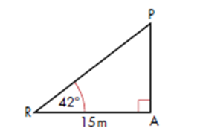

Calculate the height of the pole. Give your answer to 3 significant figures. (3)

**Question 2**

Given that sin Ɵ = $\frac{\sqrt{3}}{4}$, find in surd form the possible values of cos Ɵ.

(3)

**Question 3**

The graph of *y* = sin *x* for $0≤x≤360°$ is shown below.

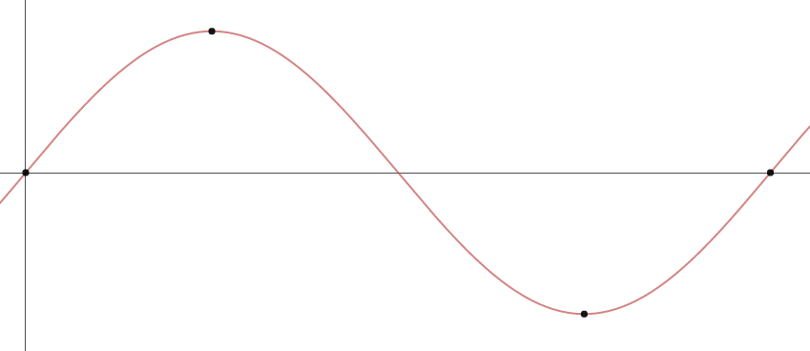

What are the coordinates of the 4 points labelled on the graph?

(………, ………)

(………, ………)

(………, ………)

(………, ………)

(4)

**Total / 10**

**10 Sine / Cosine Rule**

**Question 1**

This diagram shows a village green which is bordered by 3 straight roads AB, BC and AC. The road AC runs due North and the measurements are shown in metres.



(i) Calculate the bearing of B from C, giving your answer to the nearest 0.1o

(4)

(ii) Calculate the area of the village green.

(2)

**Question 2**

This diagram shows a logo ABCD. It is symmetrical about AC.

Find the length of AB and hence find the area of the logo



(4)

**Total / 10**