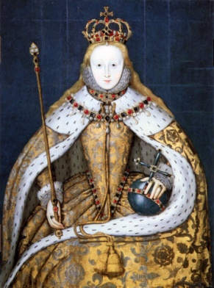**Time Guidance: minimum of 2 hours**

**Elizabethan History Pre-Course Preparation**

**Welcome to Elizabethan History!** In preparation for September we would like you to begin getting to know Elizabeth I, other key Elizabethan individuals and to get a feel for the Tudor period itself. In order to do this we would like you to complete the series of activities below. We hope that you find these enjoyable and interesting and that they provide you with a flavour of what is to come in September. We look forward to hearing your thoughts and ideas **IN THE FIRST LESSON BACK IN SEPTEMBER** when this work will be handed in to your Elizabeth teacher.

**TASK 1 - Reading – getting to know Elizabeth!**

1. Read *Elizabeth I: An Overview* (included in the pack).
2. Create a fact file about Elizabeth. Bullet point:

* The key problems in the early years
* The question of marriage
* Elizabeth’s favourites in court
* Plots and conspiracies
* Elizabeth’s final years.

**TASK 2 - Ian Mortimer, *The Time Traveller’s Guide to Elizabethan England* – getting to know Elizabeth and the Tudor period!**

Read the introduction to this book (included in the pack) and then bullet point 3 things that strike you/stand out to you about Elizabethan England at the end of it.

**TASK 3 - Fact Files – Getting to know the key individuals of Elizabethan England**

Create fact files on the individuals below, using the categories provided. Useful sites for this include:

* <http://www.historylearningsite.co.uk/tudor-england/>
* <http://spartacus-educational.com/Tudors.htm> (under ‘Tudor Figures’)

**INDIVIDUALS**

* William Cecil
* Robert Dudley
* Francis Walsingham
* Mary Queen of Scots
* Robert Cecil
* Robert Devereux

**CATEGORIES**

* Name
* Position
* Dates (birth and death OR in position)
* Influence / involvement with Queen / policy.
* Any other interesting facts

**Stretch:** Francis Drake; Walter Raleigh; Peter Wentworth; Walter Strickland; Matthew Parker; Edmund Grindal; John Whitgift.

**TASK 4 - Finally, there are a few administrative tasks that we need you to have ready for September**

1. Buy an **A4 LEVER ARCH** file and **6** dividers and bring this to the first lesson back in September
2. Ensure you have a dictionary and thesaurus at home
3. Bookmark <http://heathenhistory.co.uk/elizabeth/> as we will use this website regularly

**Inspired? If you can’t wait until September to find out more you could:**

* Visit the National Portrait Gallery in London – entry is free and it has many amazing original Tudor portraits.
* Visit <http://heathenhistory.co.uk/elizabeth/> and use the reading/watching lists to find out more about the Tudor period. This includes both fiction and non fiction.

If you need any help or have any questions about this preparation work you can contact any of the teachers below by email:

Mrs Bee – [sbee@littleheath.org.uk](mailto:sbee@littleheath.org.uk)

Mr Bond – [sbond@littleheath.org.uk](mailto:sbond@littleheath.org.uk)