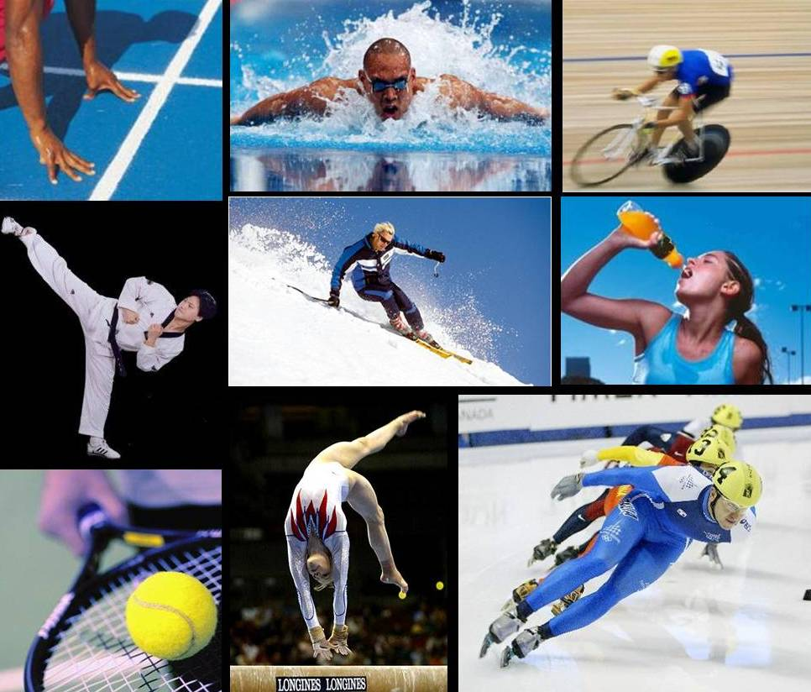**Little Heath School**

**BTEC sport**

**Level 3**

**Preparation**

The course is split into 4 units:

* 2 of these units will be exams
* 2 will be course work

The course will be over 2 years and you will be graded with a: Pass, merit, distinction or distinction*

In order to prepare for the course you will need to research the following body systems:

• Skeletal System (joints, bones, functions of the skeleton, how exercise can benefit the skeleton)

* Muscular System (muscles, types of muscles, how exercise benefits the muscular)
* Respiratory System (the function, the benefits of exercises on the system, factors affecting the system)
* Cardiovascular System (key components, benefits of a healthy cardio system, how exercise benefits the system)
* Energy Systems (key components, what each component does in relation to physical activity.

This work should be handed in by the 15th September. The notes you make will benefit you as this will be in the first exam.

Time Guidance: 3 hours