LHS Careers Events
- 210317 Army Presentation by ex- student Y10 assembly
- 220317 Y10 Chemistry Trip University of Oxford
- 230317 Oxford International Biomedical Conference- Scientists in School Symposium at LHS Y12
- 290317 Y11 Apprenticeship Assembly
- 040417 Nvdia –Innovations Day
- 050417 Y9 Business Fair Main Hall
- 050417 Y7 Engineering challenge at AWE
Careers

AWE APPRENTICESHIPS
AWE have extended their application window and apprenticeships are still available
in the following areas

- Electrical Technical Author
- Electrical Maintenance
- Electronic
- Finance and Project Controls
- Mechanical Technical Author
- Precision Machining
- Process Operator
- Quality Inspection
- Radiation protection (Health Physics)
- Control and Instrumentation
- Lab Techs
- Mechanical Maintenance

For full details please refer to: www.awe.co.uk
If there are any queries please email: aweapprentices@awecareers.co

MORRISONS DEGREE LEVEL APPRENTICESHIP
Candidates are able to work and study, coming out with a Chartered Manager Degree Apprenticeship at the University of Bradford - the salary being just over £17,000 per annum.

THE DEADLINE HAS BEEN EXTENDED TO THE 27TH MARCH MIDDAY.

The schemes they are running are:

- Retail
- Logistics
- Supply Chain
- Manufacturing
- Corporate

All the details of our roles can be found on our website - https://www.morrisons.jobs/our-teams/early-careers/sponsored-degree

Please feel free to phone them if there are any queries :01635 584141 or email degreelevelapprenticeship@morrisons.ambertrack.co.uk.

NG BAILEY EXTEND APPRENTICESHIP DEADLINE
NG Bailey based in Theale is one of the largest independent engineering, facilities and IT services business, with a history spanning almost a century. They have been involved with the development of many iconic buildings including the Silverstone Wing at Silverstone’s world famous grand prix circuit. Heathrow Airport’s Terminal 2 also known as the Queen’s terminal etc
The roles currently available in Reading are:
- Building Services Engineering Design Advanced Apprenticeship
- Building Services Engineering Advanced Apprenticeship
To find out the details of these apprenticeships please log onto www.ngbailey.com/apprenticeships
The closing date for applications is Friday 24 March 2017

THE 100 MOST POPULAR EMPLOYERS FOR SCHOOL LEAVERS
View or download copies of TARGET careers’ guides for school students and their parents and teachers.
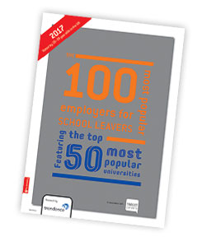
Find out more about the top 100 employers in the UK that school leavers want to work for. These employers are grouped by career sector and by region. You can also see the top 20 most popular universities as voted for by your peers.
https://targetcareers.co.uk/parents-and-teachers/313443-resource-zone

Mrs Coneley & Mrs Wooller

Job Spotlight

Abstract Artist

Peter Vaillant

British abstract artist Peter Vaillant says that there is no worst aspect to his career and that he loves creating his artwork so much, he doesn't see it as a job. We spoke to him more about his role, how he became an abstract artist and how you can too.

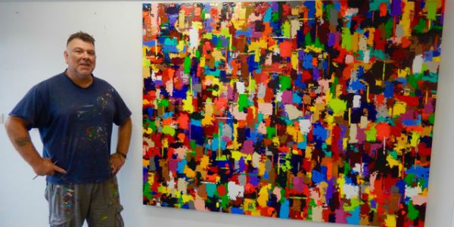"Knowing my artwork is going to be exhibited long after I am gone, feels absolutely extraordinary!"

Home town?
I was born in Exeter, Devon. I am fortunate to share my life between two abodes, at Exmouth in Devon and London. I create at both studios.

What job do you do?
I am a British abstract artist; producing distinctive and exclusive art. It is strange to think that what I do is my job, as I love it so much.

How did you become an artist?
As far back as I can recall, creativity and talent have always been characteristics that I have possessed. My family have always expressed and understood that as a child, my wellbeing and pleasure came from art. I was not one for sitting in front of a television.
Seeing someone take that journey to purchase a piece of my work, is an indescribable feeling.
This quality has never left me. I remember at a very young age being entered into art competitions at local events and winning them. This is when I believe I became an artist.
I still enjoy the moments beginning a new artwork (the larger the better for me) and the challenges of producing and discovering the direction the creation is taking, still excites me today. I followed the format most artists do: college and then university. For me this was an adventure. Discovering ‘Art and Art History’, being challenged to explore the meaning in art and pursuing excellence is how I would sum up my experience of education. I had a great art lecturer, who allowed me to express myself, not conforming to the establishment. You have great teachers and those who have chosen the wrong vocation. Just be mindful of input. I spurred on knowing I needed to create.

What qualifications do you have?
I have a Graphic Design and Audio Visual Design Degree. I also have an Art Foundation Course Diploma.

What do you do for your job?
Every day is different and I have two studios where I produce my artwork. As with the creative side, there is also an administrative element that requires time to be addressed.
The days can be used to formulate ideas for creating artwork, engagement with galleries that represent me, liaising with clients on commissions, updating websites and social media channels, and most importantly, to relax, ensuring not to tire.

What is the best thing about your job?
I don't really see it as a job. The word job for me conjures up images that I need to do it, a repetitive element governed about my life. I am able to get up when I wish, have lunch when it is convenient and leave when I need too. The best thing, is when I finish a piece of artwork and get to see someone fall in love with it as much as I do! Seeing someone take that journey to purchase a piece of my work is an indescribable feeling.
Knowing my artwork is going to be exhibited, long after I am gone, feels absolutely extraordinary!

What is the worst thing?
In my opinion, there is no worst aspect in this career.

How do I become an abstract artist?
1. First of all, take the opportunity to educate yourself in Art History. Not just within the establishment of higher education, but throughout your lifetime. There are millions of artists on this planet, not including those who have passed. This journey into knowledge will unlock some very exciting doors to the future paths you take in your own art. Don't perceive yourself as to be the first to have discovered a technique.

2. You need a studio. Unfortunately today there are venues which house studios that are more profitable to the landlord than the artist. You need to be confident and believe in your art. You are the artist: you will be the one to diversify in your action.
I find it quite strange to listen to the views of other artist trying to explain my artwork, unless they have the power of telepathy then it is fruitless and counterproductive. Art is a dedication, be prepared to spend long periods alone, enable the skill to manage your family life with your art life, they are two completely different entities.

3. Exhibit your artwork. At the beginning of your career, as an artist, you do not have to spend thousands of pounds on venues to exhibit your artwork. There are differing social media aspects which can be utilised to begin your journey. Take part in open studio and art trail events to display your artwork. Be mindful though and be prepared: you are opening up yourself to criticism, judging and copying by other artist. The criticism and judging is subjective, so try not to worry too heartily about this, as you will have positive comments expressed also. Copying takes place in all walks of life, take it as a complement that another, I will not call them an artist, has found your expressionism so overwhelming that this is all they can focus upon.
I truly believe ‘abstract art’ is not a technique or an easy way to become an artist. It is not a discipline where you create anything and call it abstract. While creating abstract art is a highly intuitive process, it takes research, study and practice to master.

