Careers
LHS Careers Events
- 060317 National Apprenticeship Week – Speakers in school at all assemblies
- 090317 Y8 AWE Female Engineering Challenge
- 160317 Fire & Rescue Team
- 210317 Army Presentation by ex- student Y10 assembly
- 220317 Y10 Chemistry Trip University of Oxford
- 230317 Oxford International Biomedical Conference- Scientists in School Symposium at LHS Y12
- 200317 Y11 Apprenticeship Assembly
- 300317 Network Rail Community Event KS3 LHS
- 040417 Nvdia –Innovations Day
- 050417 Y9 Business Fair Main Hall
- 050417 Y7 Engineering challenge at AWE

RECRUITMENT EVENT FOR NHS APPRENTICES
20 March 2017 6pm: 8pm
The NHS Foundation Trust is holding a recruitment event at the John Radcliffe Hospital for a variety of apprenticeships, including Business Administration and Clinical Healthcare. The successful candidates will commence their roles in September 2017. The venue is: The Academic Centre, Lecture Theatre 1 Foyer Level 3 John Radcliffe Hospital.
www.ouh.nhs.uk/hospitals/jr/documents/jr-hospital-sitemap.pdf

Alternatively please contact: aaprenticeship@ouh.nhs.uk
Or call 01865 226 695 or visit: www.ouh.nhs.uk/apprenticeships

ENGINEERING & SCIENCE SCHOLARSHIPS
The Worshipful Company of Coachmakers, in conjunction with Jaguar Land Rover, has a valuable series of scholarships for young women studying STEM subjects at A Level and who intend to go to university to Read Engineering or Science. The scholarships are worth £3,000 per year over three or four years (depending on the course). The successful applicants will be given the unique opportunity for extended placements during their summer terms over all three or four years of their courses and also to have access to an engineering mentor at Jaguar Land Rover to help guide and shape their futures. Interested students should down load an application form at www. coachmakers-jlr-women-in-engineering-scholarship-application.pdf and email it to: clerk@coachmakers.co.uk
CULHAM ADVANCED APPRENTICESHIP SCHEME
20 March 2017 at 6pm
The UK Atomic Energy Authority based at Culham is hosting a recruitment open day event for students interested in following an advanced apprenticeship career path.
To apply for the Engineering Advanced Apprenticeship Scheme, applicants should have obtained, or expect to obtain: Maths (higher paper) and English Language GCSE – C grade or above (or Grade 4-9) or an academic equivalent. In addition, applicants will need three other GCSEs (or equivalent) including a Natural Science, Engineering or Technology related subject at C Grade or above (or equivalent), or as an alternative, Engineering vocational qualification Level 3 of 90 credit value (540 GLH).
Students should also be able to demonstrate an interest and aptitude for practical work. Applications should be submitted by the end of March. For lots more information please refer to: http://www.culhamapprenticeshipscheme.com/

STUDENTS INTERESTED IN CYBER SECURITY
To take part in a competition related to cyber security please take a look at this: Cyber Security Challenge UK: www.cybersecuritychallenge.org.uk/competitions

ERNST & YOUNG (EY) OPEN EVENING
9 March 2017 17:30 : 19:00
The EY “Choices” evening is aimed at students from Yrs11-13 and is taking place in their Reading Office: Apex Plaza, Forbury Road, RG1 1YE. EY are a global professional services firm offering apprenticeship opportunities to hundreds of young professionals across the UK. They offer solutions to businesses of all sizes and sectors over a wide range of problems and help them comply with legislation. EY offers a solid career foundation complete with the Chartered Accountancy qualification and rounded professional training. The open evening will show school leavers what life's like at a leading global business, illustrate the different options available at EY and there will also be the chance to meet current trainees and senior people. For more information please refer to the web site: www.ey.com/uk/en/aboutus

EY - SMART FUTURES PROGRAMME
EY have now opened their Reading applications for their Smart Futures programme which is a ten month programme that commences with 3 weeks paid work experience, offers young people a mentor and provides a series of ongoing networking events. To be eligible to apply students must fulfil the following criteria:
- Currently in Year 12 (England)
- Eligible for free school meals at some point in the past six years
- Attending a state school
- Studying any combination of A-level/International Baccalaureate/BTEC Level 3s/Standards/Highers
- Ambitious and motivated to join the world of work
- Looking for a great paid work experience this summer or Easter* that will help you secure a job after school, or a place at university.
To apply, please go to:
www.ey.com/uk/en/about-us/corporate-responsibility/ey-foundation-smart-futures-apply

Y12 & Y13 WORKSHOPS AT THE UNIVERSITY OF NOTTINGHAM

8/9TH April 2017
A two day intensive revision workshop for Y12 students wanting to improve A Level grades in Chemistry, Biology and Physics. www.workshop-conferences.com

15/16th July 2017
A two day practical workshop for Y12/13 students wanting to study medicine
www.medlink.uk-uk.net

15/16th July 2017
A two day practical workshop for Y12/13 students wanting to study veterinary medicine. www.workshop-conferences.com

Mrs Coneley & Mrs Wooller

Job Spotlight
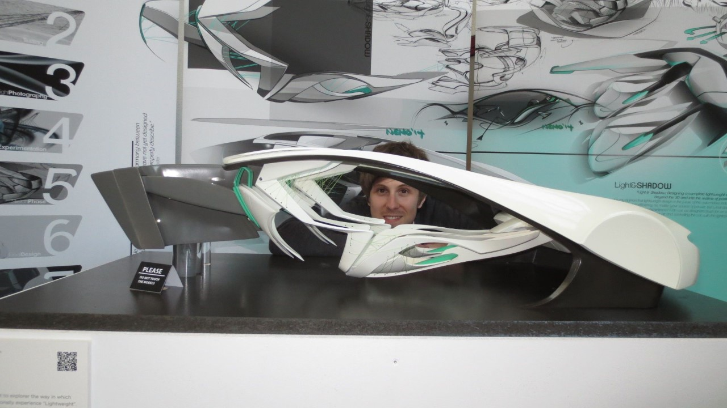

Car Interior Designer

Matthew Hunt

Ex LHS Student

Please enjoy a recent letter that I received from a very proud dad!

“Hi Eileen,

I hope things are going well at Little Heath!

As the Careers Teacher at Little Heath I thought you like to know about the achievements of one of your former pupils, my son, Matthew Hunt, who left Little Heath over 10 years ago in 2006. This is something that not only am I very proud, but for which Little Heath School should also be very proud as it was at Little Heath where he started his journey towards his eventual career. Feel free to share this with teachers and pupils at the school (including the images, etc. from the web site link below). And, if they are still at the school I would like you to pass on my thanks to his former teachers, in particular the help and encouragement from Mr Kydd, his 6th Form Tutor and Mr Rainer, his 6th Form Maths Teacher.

When Matthew was 15 and trying to decide which subjects to study at ‘A’ Level I asked him ‘What do you want to do when you leave school?’ He answered ‘I want to be a Car Designer!’ This was a surprise to me as it was the first time we’d had this type of conversation since he was about 9 years old and said he wanted to be a Premier League Footballer!

However, what it did was to crystalize which subjects to study at ‘A’ Level. So, we decided the best ‘A’ Level subjects for him to take were Maths and Physics, which are the subjects needed to understand the engineering side of Car Design, and Art, to develop the artistic flair needed for Car Design.

After Little Heath Matthew studied Car Design at Coventry University, graduating in 2010 but was unable to secure a job within the car industry. He had a year working in a call centre to earn some money but still wanted to become a Car Designer so decided to do a Master's degree in Car Design at Umea University in Northern Sweden. This turned out to be an inspired choice as the University has a fantastic reputation within the Car Design community. During his course he spent a year in Munich working for BMW which led to his final year project - a Car Interior Design in conjunction with BMW.

Then at the degree show when graduating in 2014 Mercedes saw his design and offered him a job at Mercedes' Car Interior Design Centre at Lake Como in Northern Italy, which he accepted. In the car design industry for each new model many car designers put forward their initial sketches which the Chief Car Designers review to choose which ones to progress further. Then after many months they whittle the designs down to what they consider to be the best 3. These are then created as full size models (in Matthew's case he specialises in designing car interiors) for final selection by the main board. For young designers just out of University it is rare for their designs to make it beyond the early sketches stage.

Over the last couple of years Matthew has put forward several designs which have encouragingly progressed through the initial stages of selection. Two in particular even got selected to be made into full size models. One for the new version of the Mercedes 'C' Class and one for a Mercedes Hypercar to celebrate 50 years of Mercedes Cars. Just before Xmas was the final selection for the interior design of the Mercedes Hypercar and Matthew's design won! Then a couple of weeks ago was the final selection for the Mercedes 'C' Class and Matthew's design won that too! The 'C' Class 'win' was not only a big deal for Matthew.
It was also a big deal for his design studio, being only the second design 'win' of a major production model for the Como Design Centre in the last 8 years!

The Mercedes 'C' Class won't be coming out until the early 2020's and the secrecy within the car industry means that he cannot show pictures of it to anyone so I have no idea what it will look like! But for the Hypercar, called 'Mercedes-AMG Project ONE' which is due to be unveiled next September, Mercedes have just release the first tantalising pictures of what it will look like, so please take a look at this web site:-
https://www.mercedes-benz.com/en/mercedes-benz/vehicles/announcement-mercedes-amgproject-one/
Matthew has put a huge amount of effort to achieve these design ‘wins’, and it’s not an easy life as there are huge pressures involved, however when we discuss these things he just says to me

‘Dad, I’m doing the job I wanted to do!’ And maybe that is the biggest achievement of the lot!

All the best,
Nevil “

………………………………………….

