

**Progression after Qualification**

**Entry Requirements**

**Further Education:**

This qualification set’s you up nicely to study any fashion or textiles course at university. The skills learned will also allow you to access other creative courses such as interior design or journalism.

GCSE Grade 4 or above in English Language.

It is not prerequisite to have taken GCSE in a Fashion and Textiles. An enquiring mind and genuine interest in fashion. Looking in depth at materials and how they are crated and used. A desire to create beautiful object and an interest in future creative careers is an advantage.

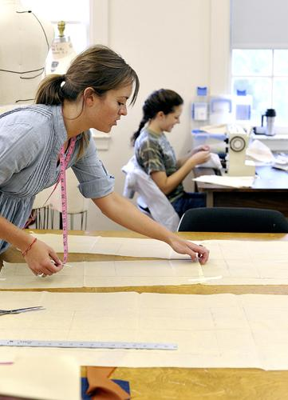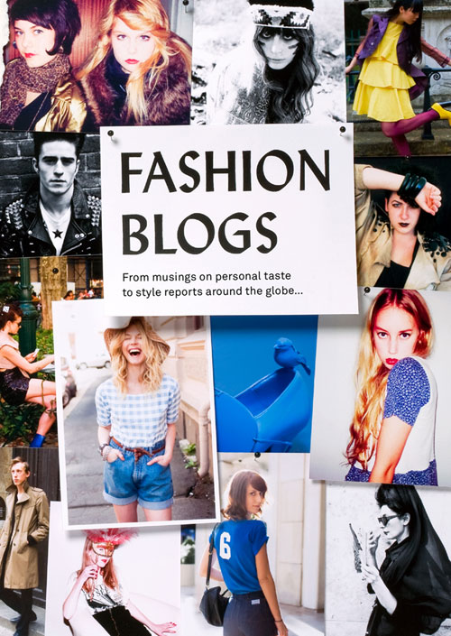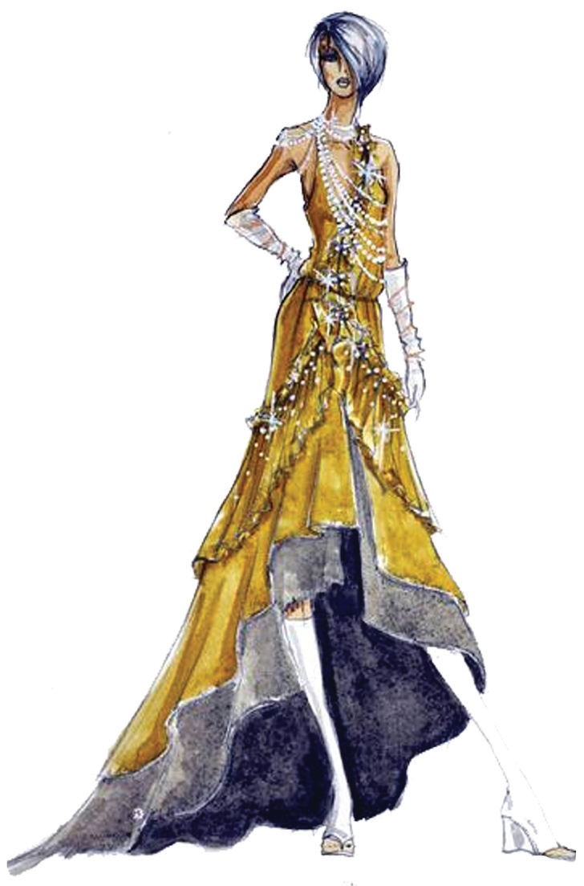

Pattern Designer

Fashion Design

Fashion Illustration

Journalism

Costume Design

Interior Design

Fashion Historian

Retail

Textiles Technologist

**Further information please contact the following teachers.**

* **Mr James**

[**jjames@littleheath.org.uk**](mailto:jjames@littleheath.org.uk)

* **Mrs McCarthy**

[**smcarthy@littleheath.org.uk**](mailto:smcarthy@littleheath.org.uk)

AQA

A Level Design Technology

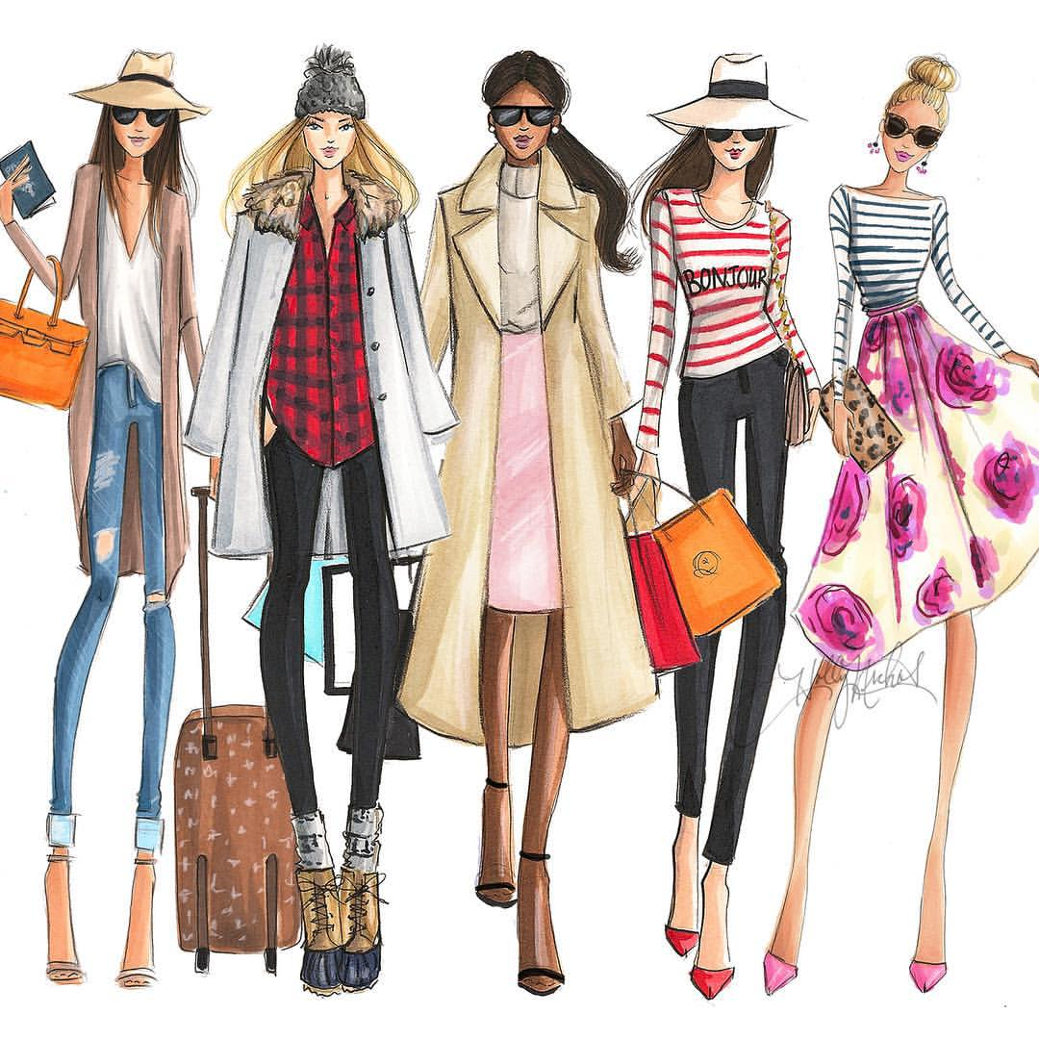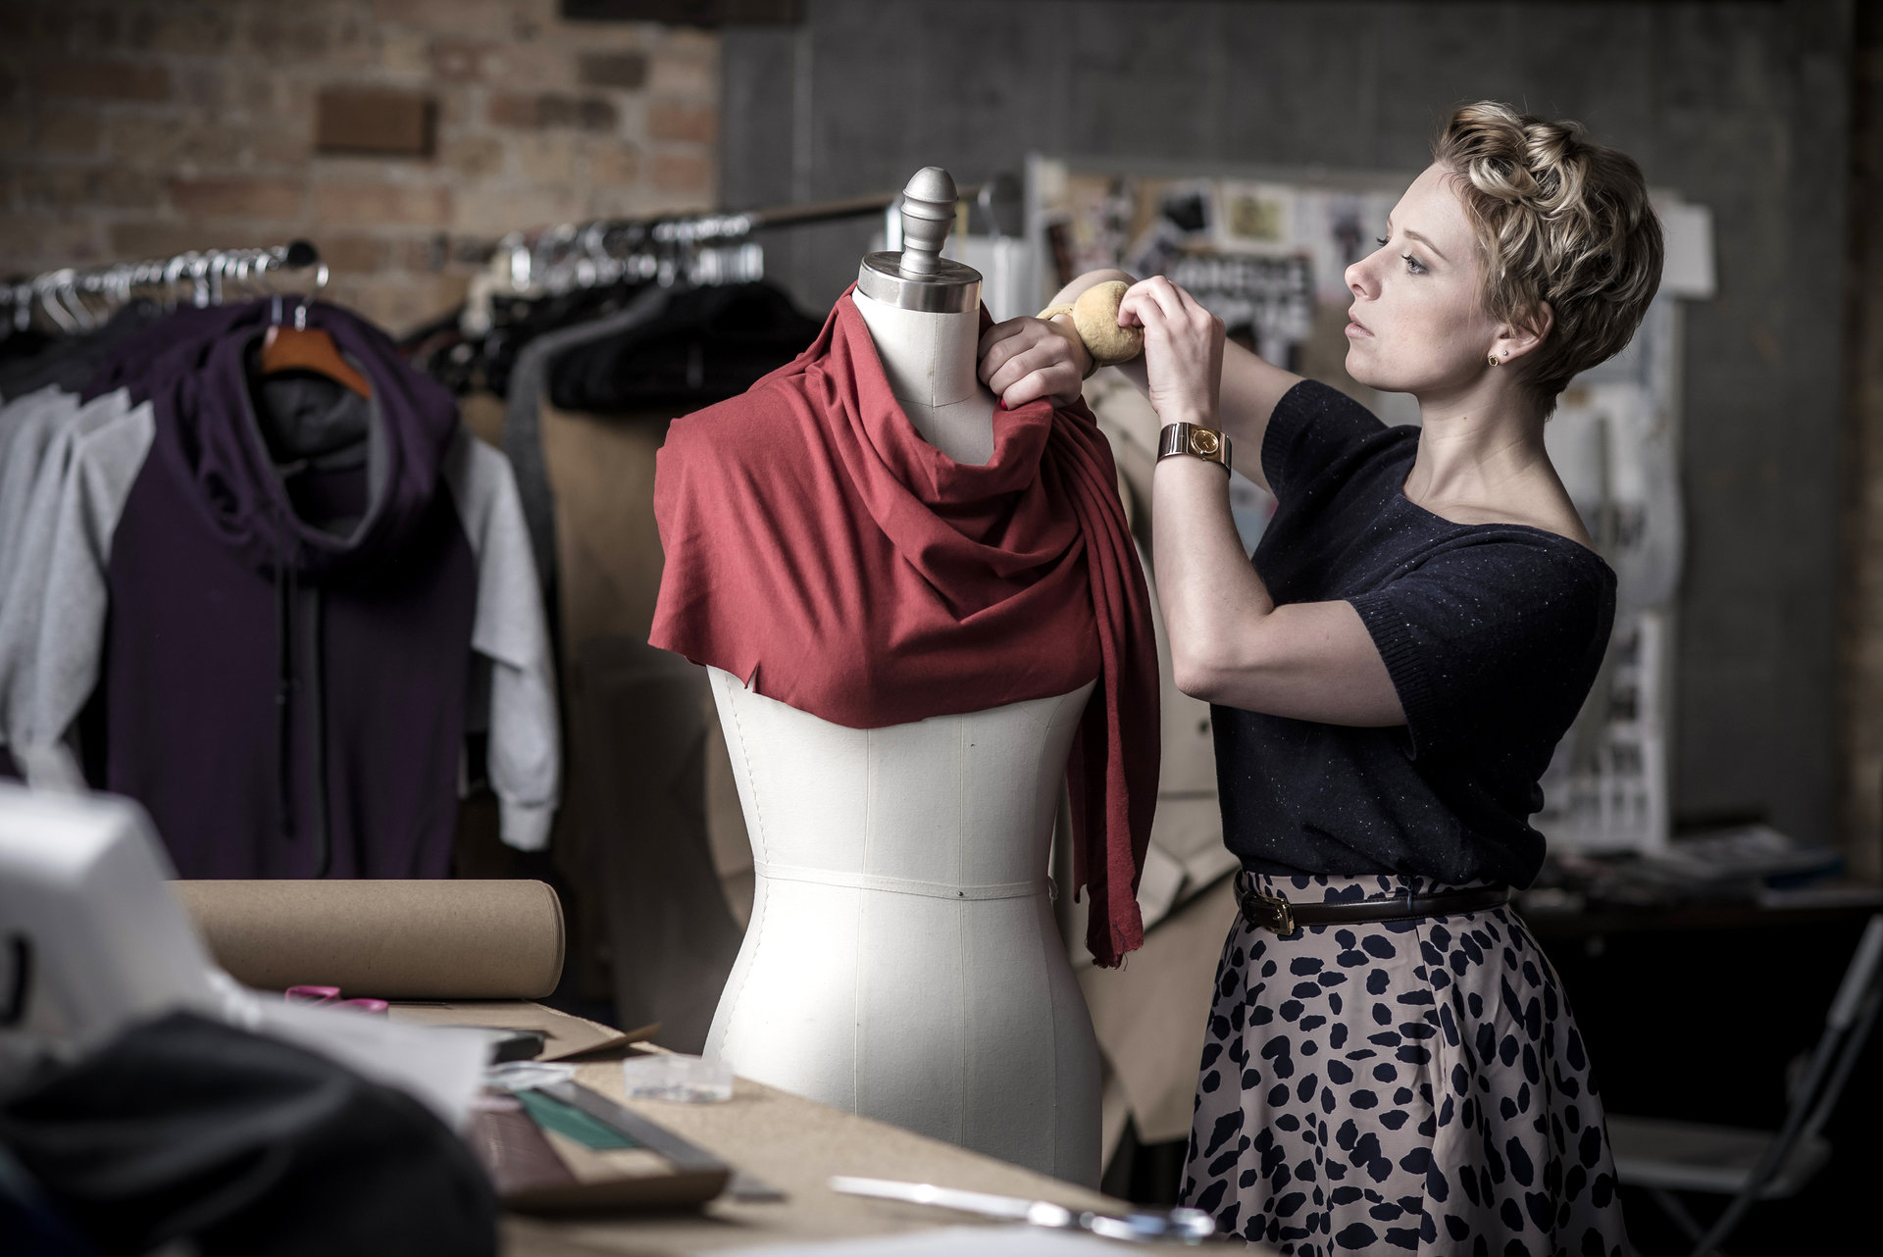

|  |  |
| --- | --- |
| Paper 1:  Technical Principles | 30% |
| 120 Marks  Mixture of short and extended question  Core principles- Theory | |
| Paper 2:  Designing and making Principles | 20% |
| 80 Marks  Mixture of short and extended question  Product analysis questions  Commercial manufacture | |
| Non examination Assessment (NEA) | 50% |
| 45 hours  Single substantial Design and make task  Written or electronic portfolio. Must include photographic evidence of practical | |

**Year 13**

**Year 12**

|  |  |
| --- | --- |
| Written Paper | 50% |
| 80 Marks  Split into two section.  Section A-Technical / Section B Designing & Making | |
| Non Examination Assessment (NEA) | 50% |
| 80 Marks  Single project  Context set by AQA. Students develop their own design brief based on the context. Released 1st June each year. | |

**What will I Study in Fashion & Textiles?**

As part of the course you will learn and build upon skills including:

-To develop your own core design skills.

-About fibres, fabrics and components.

- How to be creative and how designers get inspiration for design ideas.

-Investigating methods to colour, decorate and stitch fabrics.

**Why should I study Fashion & Textiles?**

Fashion and Textiles offers you the opportunity to begin to explore in more depth the exciting world of Fashion Design, Styling, Marketing and a wide range of other Fashion and Textiles careers, where creativity, imagination and a willingness to take risks will get you far. You will have the opportunity to go to Graduate Fashion Week and see where studying this subject could take you in the future.