1. **Memory** = looking at providing explanations of why we forget things and how to improve our memory.
2. **Attachments** = looking at caregiver-infant interactions and animal studies into attachment.
3. **Research methods** = looking at the methods of conducting psychological studies such as observation.
4. **Approaches in Psychology** = looking at different ways of studying why we do things e.g. the cognitive approach.
5. **Psychopathology** = looking at different types of mental illness such as phobias and depression.

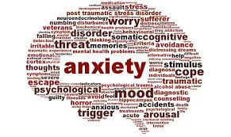

**What is Psychology?** 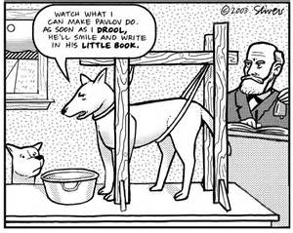

Why do we do the things we do? To what extent is our behaviour the results of our genetic inheritance as opposed to how we are brought up?

Psychologists help us gain answers to questions like these by carrying our experiments into different aspects of human behaviour.

Specific questions investigated include the following:

* How can we explain why people obey orders even if those orders have terrible consequences, such as in Nazi Germany?
* Why is our childhood so important for our development?

**Psychology Year 12 Course**

Students will study the AQA specification for Psychology. Within the first year the students will investigate six topics:

1. **Social influence** = looking at explanations for why we conform and obey to others.

**Qualifications needed**

You must gain at least five Grade A*-C GCSE passes and at least a Grade 5 in English Language and a Grade 5 in Mathematics in order to study A Level Psychology. **There is no coursework.**

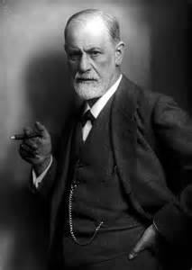[](http://www.google.co.uk/imgres?imgurl=https://blog.bufferapp.com/wp-content/uploads/2013/08/psychology.jpg&imgrefurl=https://blog.bufferapp.com/6-powerful-psychological-effects-that-explain-how-humans-tick&h=300&w=290&tbnid=1VkMddTfMyo_2M:&zoom=1&docid=hQsmazCACcWbJM&ei=Kna2VKOyBsnpaMfQgNAL&tbm=isch&ved=0CCUQMygEMAQ&iact=rc&uact=3&dur=448&page=1&start=0&ndsp=8) 

**Psychology A Level**

Students will study all of the AS topics plus five additional topics:

1. **Issues and debates** = looking at issues psychologists have to consider in their research e.g. is their research group representative of both genders?
2. **Biopsychology** = looking at the biological aspects of our behaviour e.g. what do different parts of our brain control?
3. **Relationships** = looking at why we form relationships and how they are maintained.



1. **Eating behaviour** = looking at explaining why we like and dislike certain foods, and where our food preferences originate from.
2. **Forensic Psychology** = looking at the origins of crime and reasons why people commit crimes.

**Exams**

As Psychology is a linear course it means that all topics will be assessed at the end of Year 13. There will be three exams, and they will each be two hours long.

**There is no coursework.**

**Studying Psychology**

**at A Level**