
Physics
PHYSICS

OCR - A-LEVEL

Why choose to study Physics?

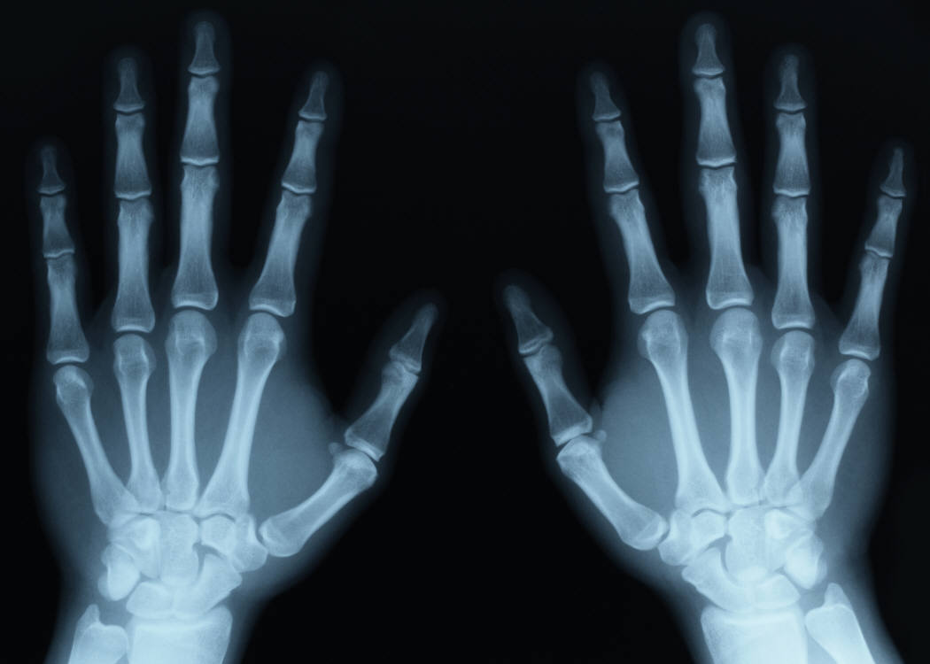
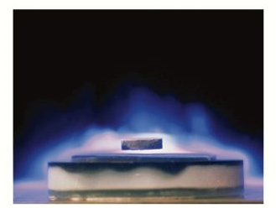
Physics is a fascinating course which has relevance to everything we do and is one of the most universally accepted qualifications for progression to university. Physicists are involved in an immense range of activities from developing materials for artificial joints to designing fusion reactors that replicate the sun. By studying the particles at the heart of all matter, through to the observation of the outer regions of the universe, you will be able to appreciate the everyday world around you and answers questions like “how does an aeroplane fly?” and “why is the sky blue?” A Physics qualification is highly valued by many employers and there is a tremendous demand from universities for students with some Physics background. If you have an enquiring mind, are adaptable and like challenges then you will enjoy studying Physics.

The Course
Key features:
- OCR Physics A is a well established course built on may years of experience, covering the knowledge and understanding necessary to progress to STEM degrees and careers.
- Emphasis throughout the course is on developing knowledge, competence and confidence in practical skills and problem solving.
- Incorporates both Astrophysics and Medical Imaging.
- Physics is one of the top three A Levels in terms of eligibility for degree entry.

We are offering a new and exciting A Level designed by OCR which is divided into topics, each covering different key concepts of Physics. As you progress through the course you will build on your knowledge of the laws of Physics, applying your understanding to solve problems on topics ranging from sub-atomic particles to the entire universe. You will integrate the concepts studied with a range of practical experiments throughout each topic giving the course both an academic and practical focus. You will learn to apply your knowledge of the key concepts to solve problems in a range of different contexts and applications. The Practical Endorsement will also support the development of practical skills.

What will I study?

- Measurements and errors
- Forces and motion
- Materials
- Electricity
- Waves
- Quantum physics
- Thermal physics and gas laws
- Circular motion and oscillations
- Gravitational fields
- Stars and cosmology
- Electric fields and capacitance
- Magnetic fields and electromagnetism
- Radioactivity and nuclear physics
- Medical imaging

Practical work is at the heart of A Level Physics and is continually assessed throughout the topics, providing evidence for the Practical Endorsement.

How will I be assessed?
These exams do not count towards you full A Level qualification.

A Level qualification taken at the end of Year 13
- A Level is covered in three examinations:
- Total of 6 hours of examinations ( 2 x 2hour 15minutes and 1 x 1hour 30 minutes) taken at the end of the A Level course.
- Modelling Physics (sections 1,2,3,7,8,9, and 10) 100 marks (37%) 2¼ hours
- Exploring Physics (sections 1,2,4,5,6,11,12,13 and 14) 100 marks (37%) 2¼hours
- Unifying Physics (all sections) 70 marks (26%) 1½ hours
- A wide range of questions types which include multiple choice, short answer and extended response questions will be used.
- 12 key practicals assessed throughout the topics will providing evidence for the separate Practical Endorsement certificate, which is a separate certificate to show practical competence in A Level Physics. (You will however carry out many more practicals than this as practical work is the best way to develop your understanding of the topics covered)
What are the benefits?
- Essential for access to physics and engineering courses.
- Highly regarded for other subjects such as medicine, law and economics because of the thinking skills and problem solving involved.
- Subject cross-over with Maths and Chemistry. Makes Maths, Physics and Chemistry a powerful combination to optimise your A Level grades.

Are you?
- Interested in getting a qualification that leads to lots of different options at university, from Theoretical Physics to Applied Physics, Engineering and Mathematics?
- Interested in STEM careers?
- Curious about how things work?
- Interested in problem solving?
- Interested in doing a wide variety of practical experiments to test hypotheses?
- Curious about how the universe works?
- Interested in how new particles are discovered?

Entry Requirements
All students need an Additional Science GCSE of grade B or higher, or a single Physics GCSE of grade B or higher. As good mathematical skills are so vital in Physics A-level you will also need a Maths GCSE of grade 6 or higher. It would also be a huge advantage, but not a requirement, to be studying A Level Mathematics.

Support and Monitoring
The A Level team is committed to helping all students reach their full potential both in and out of the classroom by:
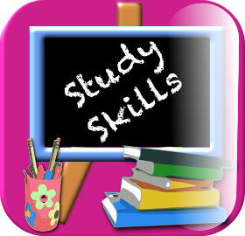
- Provide an exciting course which supports you in achieving your full potential.
- Regular homework will be set and marked within a week.
- Drop in revision sessions will be offered to help you with any areas you are finding difficult.
- A personal learning check list (PLC) will be provided for each unit these include details of the syllabus to allow you to track progress through the unit.
- Worked answers to all problem sheets, so answers can be checked.
- Numerous past paper questions, sorted in to topics. With mark schemes for you to refer to.
- Set regular progress tests to monitor your understanding of new ideas.

Where can the qualification take me?

STEM degrees, varieties of Physics, Maths and Engineering qualifications.
- Advanced apprenticeships in industry, at present aerospace, nuclear generation and electrical power distribution are the main areas within industry offering Advanced apprenticeships.
- Listed below is just a few careers that students studying A-level physics have progressed on to, there are many more.

Aeronautical engineer

Biophysicist

Cyberneticist

Civil engineer

Flight engineer

Geologist

Industrial designer

Meteorologist
Medical physicist

Nuclear physicist

Oceanographer

Optometrist

Structual engineer

Space scienctist

Teacher

Veterinary surgeon

What do the students in Year 12 say about Physics?
“Physics lessons this year have been really enjoyable use of my valuable student time”
“Physics is my favourite subject”
“The teachers are very friendly and supportive”
“Physics gives the last 5 years of maths a purpose”
“I took physics as a last minute subject, but now I really enjoy it”

You will find Physics A Level a stimulating and rewarding experience, developing invaluable skills which you will find useful for any degree or future career.

If you are interested in studying Physics in the sixth form and would like more information please talk to:
Mr Boddaert or Mrs Berrios

Or you can email; dboddaert@littleheath.org.uk

