What is the Music Technology Course about?

Music Technology A Level is one of the most exciting and interesting courses available and gives you the ability to develop a number of different skills

You will have the opportunity to:
- develop your skills as sound engineer, recording and editing performances
- produce cover versions and arrangements in a number of styles
- use computers and music technology to compose, arrange, perform and record your work
- work on high level composition projects
- Analyse popular music styles from a wide range chosen by the exam board including:

  - Rap and Hip-Hop
  - Rock & Roll
  - 80s Synth Pop
  - Heavy Rock
  - R n B
  - Indie
  - Reggae

What life-skills will Music Technology help me to develop?

A Music Technology course helps you to:

develop self-discipline
develop creativity, inventiveness and initiative
learn to work with others as a member of a team, developing an awareness and sensitivity to others
learn to accept responsibility
learn to organise the work of others
- develop co-ordination, flexibility, adaptability, self-awareness, self-confidence

All the above are vital skills that both British industry and Further Education Institutions need in young people!

Over the past 20 years, income from music-related sources has been a crucial part of the UK Gross National Product and the Music Industry is now the UK’s 2nd largest employer!!

 
How will Music Technology be useful to me in my future career?

Most employers are interested in people who have followed a broad and balanced range of subjects to an advanced level. The study of any form of music is essential in some careers and a valuable asst in others:

Acoustic engineer Primary Teacher
Advertising Publishing
Architect Radio
Arts administration Recording Studio
Box office worker Engineer
Instrument technician Rock and pop industry
Instrumental teacher Secondary Music Teacher
Journalism Sound engineer
Librarian Software programmer
Music therapist Solo performer
Nursery Nurse Special School teacher
Occupational therapist Theatre
Performer Tourism

Grade C and above at GCSE is recommended for entry to A Level Music Technology, but you can take A Level Music Technology even if you have not studied GCSE Music (although reasonable keyboard skill are highly desirable).

WHY Study A LEVEL
MUSIC TECHNOLOGY?

You will shortly be deciding whether to study Music Technology in Years 12 and 13.

Here are some important questions which you should ask.

What is the course about?

What life skills will Music Technology A Level help me to develop?

How might Music Technology be useful to me in my career?

Will it be a good A Level to get me into university or further study?

This leaflet gives you information to help you make your decision.

If you require further information, please contact a member of the music staff who will be pleased to help you and answer any questions you might have about the course. If you are not currently at Little Heath student, please contact the Music Department on the number below.

Miss Roberts (Head of Music)
Miss Hancock
Mr Davies

You may also refer to the Edexcel website for detailed information about the current specification.
www.edexcel.com

   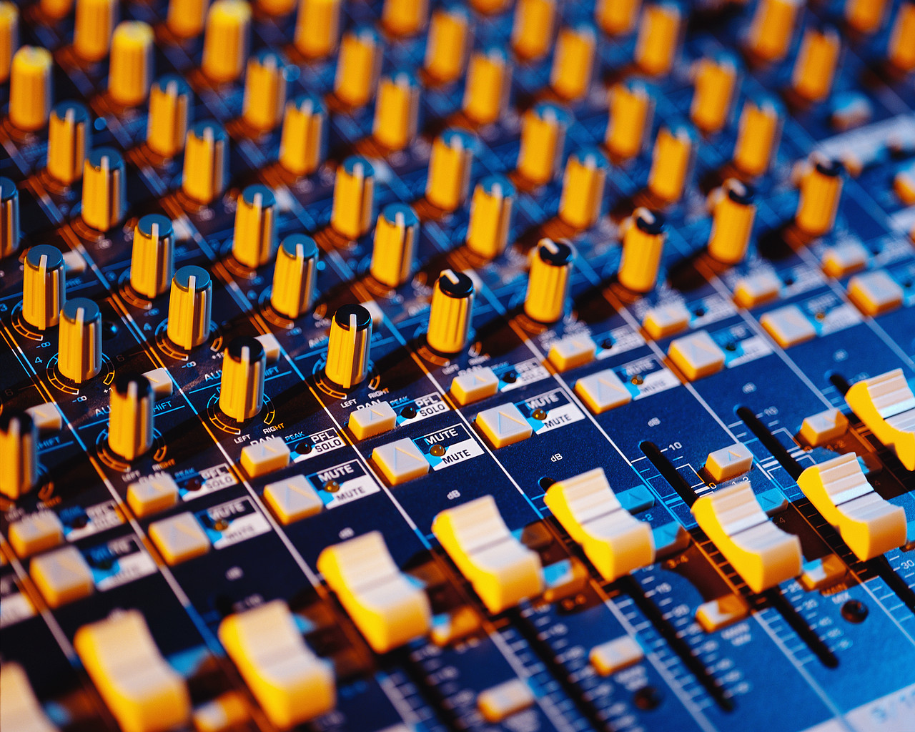

Little Heath School, Little Heath Road,
Tilehurst, Reading RG31 5TY
Tel. 01189 427337

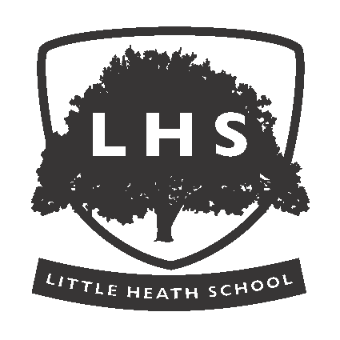

OPTIONS:
A LEVEL MUSIC TECHNOLOGY

  

