LIBRARY and I.T. FACILITIES

Open from 8.15 am to 4.15 pm daily
Library Assistant Mrs Waggoner mwaggoner@littleheath.org.uk
Library Manager Mrs Cossey hcossey@littleheath.org.uk

The library provides a peaceful and purposeful area in school where you can study. There is a wide range of fiction available, together with a large selection of non-fiction books which have been specially selected to support the curriculum. Fiction is shelved by author surname and all non-fiction books are shelved according to their Dewey Classification Number. Information on the Dewey numbering system is available on the sixth form library desk and details of all books available (including location and Dewey number) can be found on Eclipse.net the school library system. If you would like help finding resources, Mrs Waggoner is always happy to help.
Please note that there are some books in the library that are for ‘Library Use Only’ and these books cannot be loaned out, they are available for students to refer to whilst working in the library only. There is a range of careers and higher education information on display in the library. University prospectuses are available to take away, along with leaflets on numerous careers and related opportunities. There are books to help you when completing your UCAS application and personal statement. Daily newspapers and a selection of magazines are also available.
In addition to the main sixth form library, there is a computer room where sixth form students can complete work when they have ‘study periods.’ Both the sixth form library and adjoining computer area are both designated ‘Quiet Study’ areas.
There is a ‘Code of Conduct’ detailing how students are expected to behave whilst in the the library and adjoining computer room and this is clearly on display in both areas. You are not allowed to eat or drink in either room and need to always be doing something purposeful, or you will be asked to leave.
There is a printer available in the library. Please note that we monitor individual student printing, therefore, you need to ensure that you are selective when printing. Think before you print!

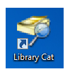
Eclipse.net School Library System

Click on this icon on your desktop to view the school library system and bring up the library home screen
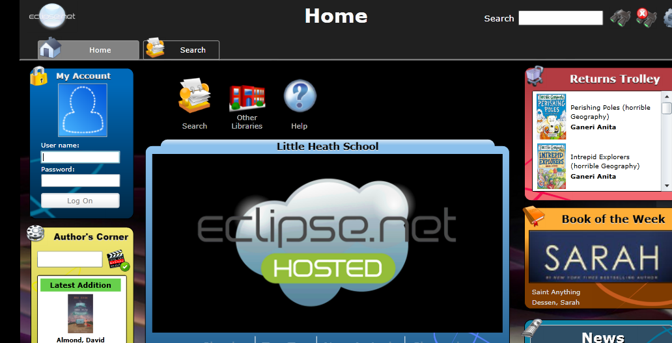

Search
On the top right hand side of the screen there is a white search box and you can use this to start searching the library catalogue. The library catalogue shows all the books that are available in the Sixth Form and Main School Libraries and gives direct links to useful websites.
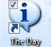
The Day On-Line Daily Newspaper
Click on this icon on your desktop to view “The Day”

See what’s happening in the news today
Read news stories that are relevant for all subjects in school
Get help with understanding the context and background of news stories
Find information to help you with homework/research
Use keywords to search thousands of articles
Find activities, debating points and ideas for further research

(Both the School Library System and “The Day” can be accessed from home by using the links on the Library Page of the School Website)

Complete Issues
Log in to Complete Issues to find interesting articles, reliable statistics and websites to help with research.
Log on to www.completeissues.co.uk
Username : littleheath
Password : information
iPads
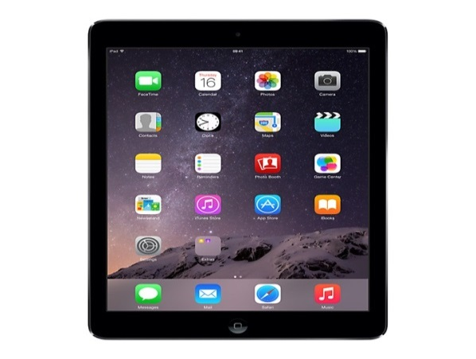
iPads are available for use in the Library and adjoining computer room. If you would like to use one then please ask at the library desk. Please note that you will be required to sign for the iPad when you take it out and it will be logged out in your name.

