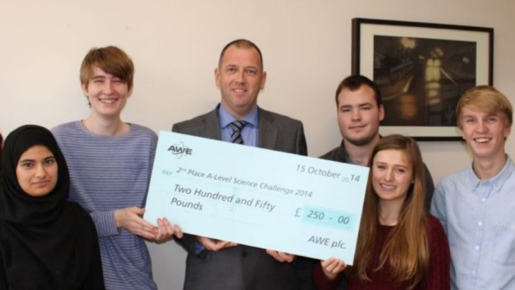

**Chemistry**

**A level at**

**Little Heath School**

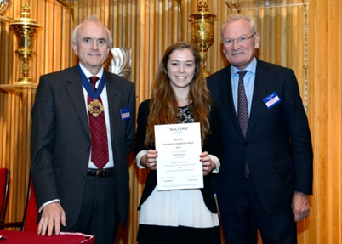

**Syllabus: Salters Chemistry (OCR B)**

# **Entry Requirements**

* Grade B (or above) in GCSE Chemistry or Additional Science
* Grade 6 (or above) in GCSE Maths (it is also recommended that students studying Chemistry also study AS Mathematics)
* Grade 5 (or above) in GCSE English

**Course Outline**

The Salters Advanced Chemistry course is divided into ten teaching units, five are taught in Year 12 and five additional units are taught in Year 13. A visit to Reading University Chemistry Department (July of Year 12) is also part of the course.

**Elements of life**

Consolidation of the basic chemical concepts including the atom, balancing equations and calculations.

Developing fuels: Hydrocarbon chemistry and how we use these chemicals to obtain energy.

Elements from the sea: The halogens and their chemistry (where do most of our halogens come from?).

The ozone story: The chemistry of our atmosphere and the essential role of ozone.

What’s in a medicine?: How medicines are developed and the chemistry involved.

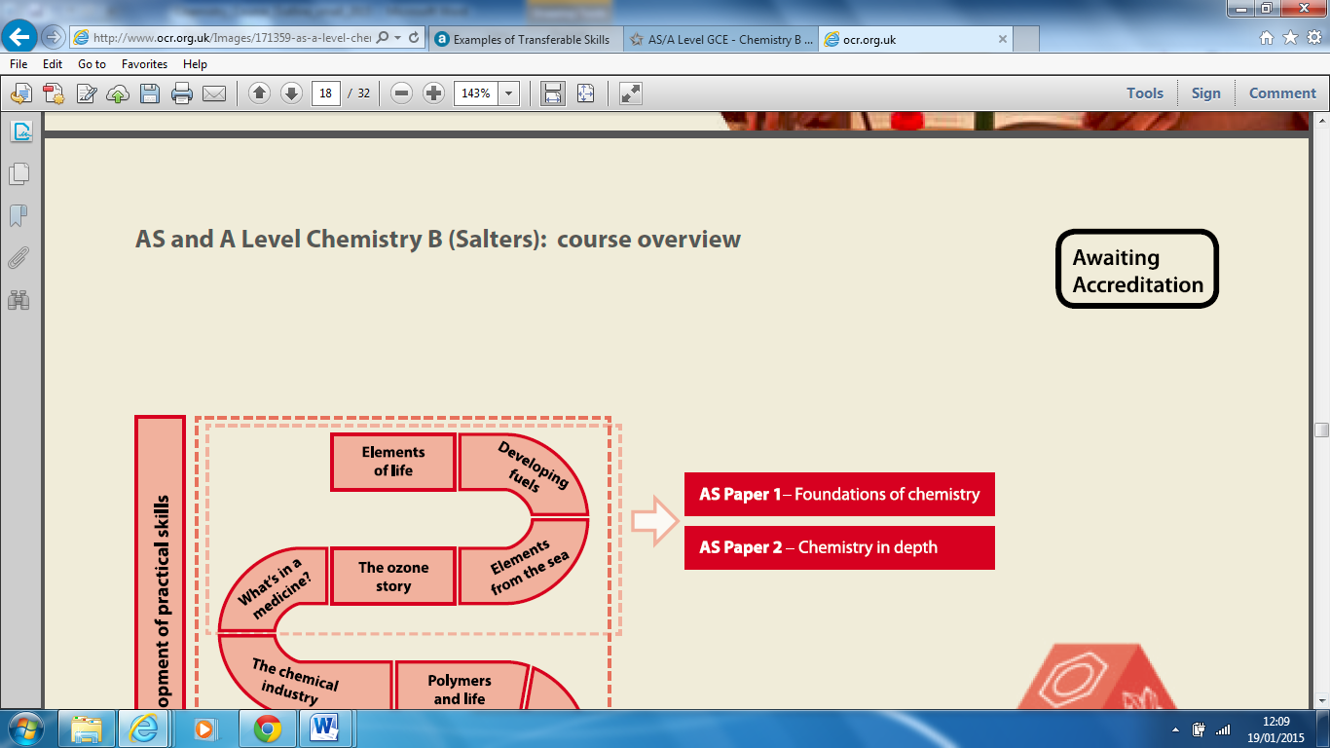

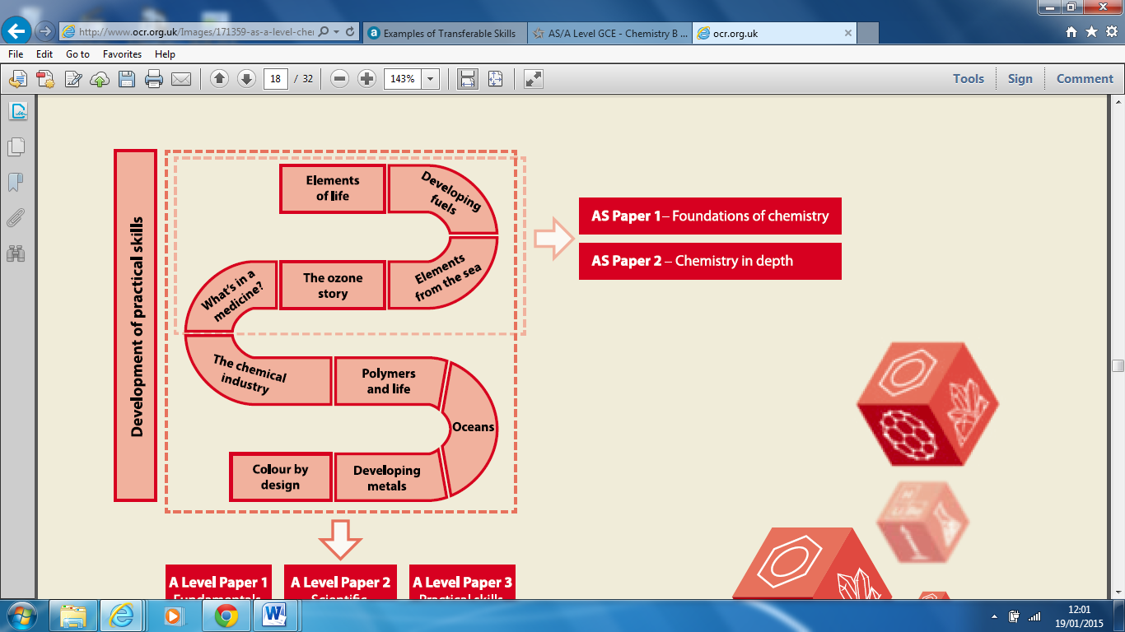

**Year 13**

The chemical industry: How chemists use industrial processes to benefit mankind.

Polymers of life: Polymers, proteins, enzymes and DNA (it is more chemistry than you think!).

Oceans: The chemistry of water and how it is essential to life (as we know it) on Earth.

Developing metals: How modern metals are obtained and improved using an understanding of their chemistry.

Colour by design: The chemistry of colour, how dyes are made and how they attach to fabrics.

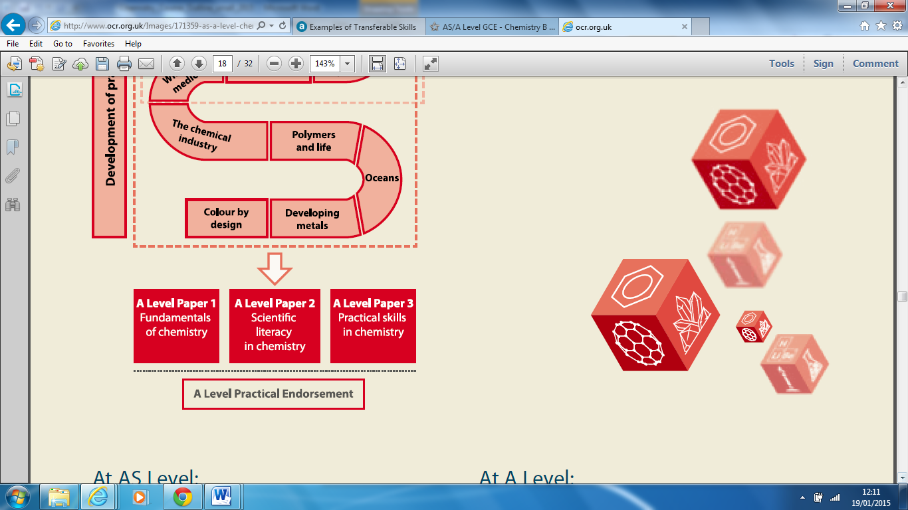

**Assessment**

### All students will sit AS Chemistry in the exam period in May/June of Year 12.

* Foundations of chemistry (Paper 1) 50%
* Chemistry in depth (Paper 2) 50%

It is very important that students return after AS study leave prepared to start the A Level course. A Level Chemistry will be assessed by examination in June of Year 13.

* 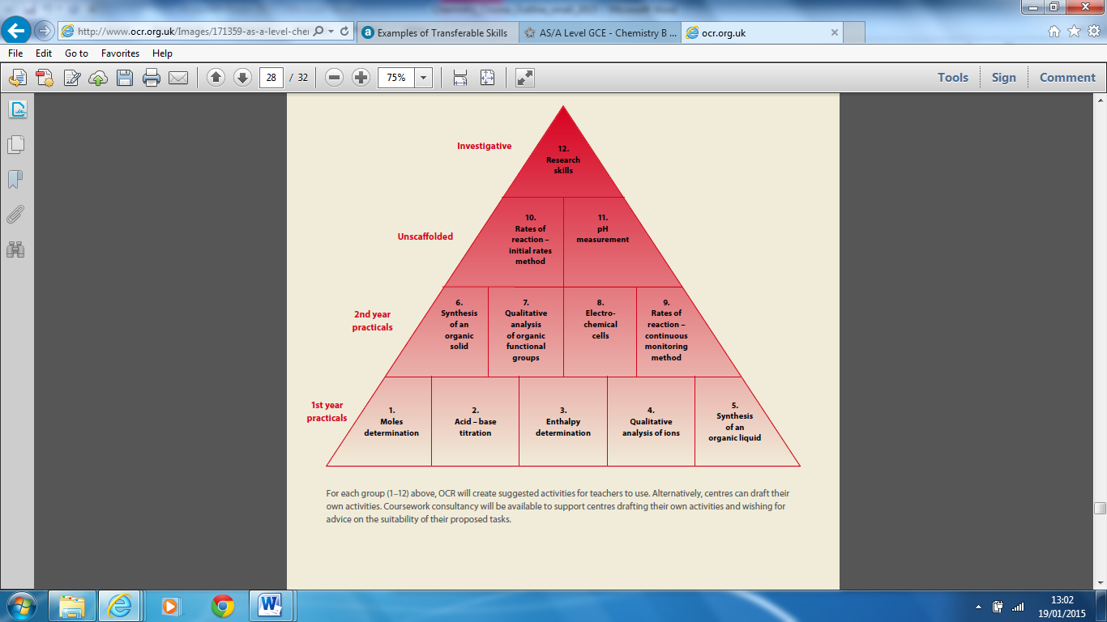Fundamentals of chemistry

(Paper 1) 41%

* Scientific literacy in chemistry

(Paper 2) 37%

* Practical skills in chemistry

(Paper 3) 22%

* Practical endorsement

12 practical activities

throughout the course (Pass/Fail)

**Support and Mentoring**

The chemistry department

aim to provide the students

with the support they need to

achieve their best.

As part of this we do the

following:

* Give the pupils a printed set of learning objectives for each unit of study.
* Set regular progress tests to monitor their understanding of new ideas.
* Maintain a record with each student that tracks test marks, goals and target grades.
* Provide extra support for students with homework, coursework and any other questions (Chemistry Catch Up: Wednesday 3.30pm to 4.45pm, C10).
* Make available numerous past exam papers with mark schemes for each of the examinations.

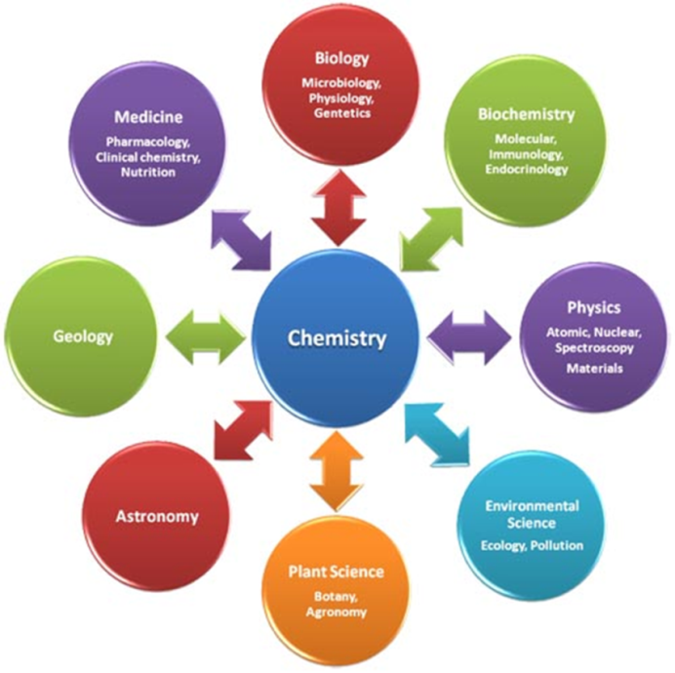**Where can A Level Chemistry lead you?**

A level Chemistry is an excellent qualification which allows students to access a wide variety of higher education courses and careers.

It is required for University subjects such as Medicine, Dentistry, Veterinary Sciences and is a highly regarded A level in terms of the transferable skills it allows students to develop.

* Communication & literacy.
* Team working & problem solving.
* Numeracy & application of IT.
* Time management & independence.
* World of work awareness and how chemistry is applied to everyday life.

**Other Information**

Little Heath School takes part in the International Chemistry Olympiad

(Through the Royal Society of Chemistry).

This occurs in late January/early February each year.

All participating students receive a commendation, some have achieved silver or a bronze medal (could you get a gold medal and represent the UK?).

Our department has a history of excellent results with many students going on to University to study Chemistry or a related field. In the past 5 years three students have been accepted to Oxbridge to study chemistry/natural sciences.

*The current Year 12 & 13 teachers are Dr J. Kissick, Miss M. Dimbylow, Mrs S. Millington-Lee and Mrs M. Dharurkar. Please contact Dr. Kissick (Leader of Chemistry Courses;* [*jkissick@littleheath.org.uk*](mailto:jkissick@littleheath.org.uk)*) if any further information is required.*