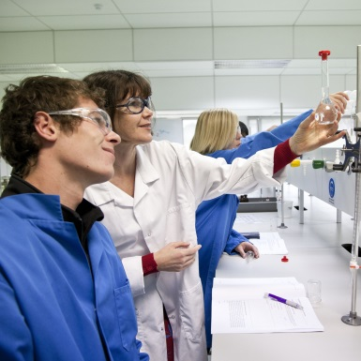

**Applied Science**

* **Do you want to learn how science applies to everyday life?**
* **Do you want to learn about the benefits and difficulties that use of science has within our society?**
* **Do you want to understand the ethical issues surrounding science in today’s society?**

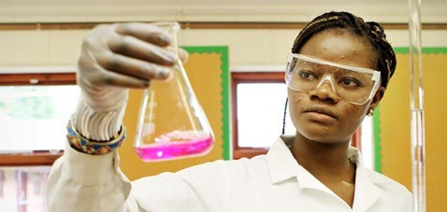

Science is the foundation of our understanding of the world we live in. The Applied Science A Level course will deepen your understanding of the real science used daily in a wide variety of businesses and organisations. Through various technical activities, you will develop your practical skills, often using more advanced equipment and chemicals not usually used lower down the school. This focus on real laboratory work is backed up with coursework tasks set in realistic work situations. This all means that Applied Science gives you an interesting, flexible and useful vocational qualification with many transferable skills.

There are two modules which are taught across the two years. These include practical tasks and assessed tasks

**What is this course**

Unit 1: Principles and Applications of Science

* Students are required to sit a 90 minute written exam which is worth 90 marks; the exam is split into three equal sections (Biology, Chemistry and Physics). The exam will include a range of question types including multiple choice, calculation, short answer and open response.

Unit 2: Practical Scientific Procedures and Techniques Level:

* This is internally assessed and students will be introduced to quantitative laboratory techniques, calibration, chromatography, calorimetry and laboratory safety, which are relevant to the chemical and life science industries.

**What do I need to do to get on this course?**

The topics extend the knowledge gained during the Additional Science GCSE as well as complementing other AS courses such as PE and Health and Social Care. They prepare you for vocational and Higher Education courses such as midwifery, nursing, sports science and coaching as well as Bachelors in Education courses.

To gain the foundation needed to do well on this course you need a good set of GCSE results as the course can be quite demanding, this includes at least at C in Maths and English. If this is not gained, then extra help will be given through the coursework lessons.

Ideally if you have an interest in Applied Science AS Level then you should be aiming for a C grade in GCSE Additional Science.

**What help is there?**

Every week there are catch-up sessions to ensure that you do not fall behind on the coursework,

Which makes up a significant part of your overall grade.

There will also be revision sessions leading up to your exams.

For more information talk to: Ms M Dimbylow, [mdimbylow@littleheath.org.uk](mailto:mdimbylow@littleheath.org.uk)