**[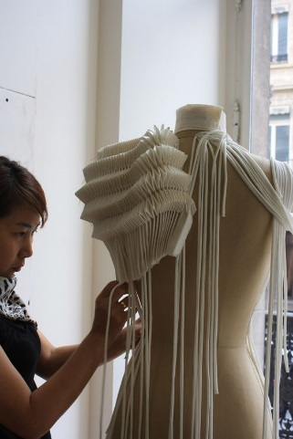](http://www.arts-of-fashion.org/SummerMasterClass/2011/images/Christine/pages/MasterClass%20Christine%20-%20133.html)**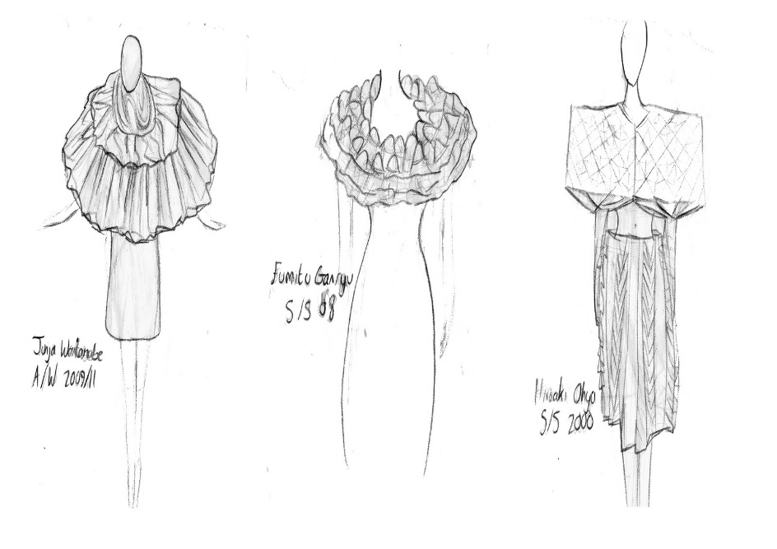[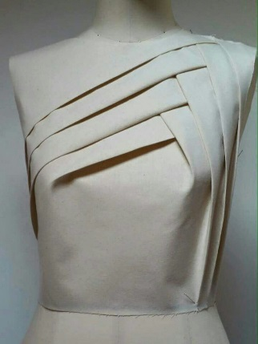](https://www.google.co.uk/url?sa=i&rct=j&q=&esrc=s&source=images&cd=&cad=rja&uact=8&ved=0ahUKEwjftJCDqOHNAhUCLMAKHWtsAbkQjRwIBw&url=https://www.pinterest.com/pin/25684660354207942/&psig=AFQjCNGZkfYj0tVymbAQxgs0SKFIxLmJrg&ust=1467979510439670)**[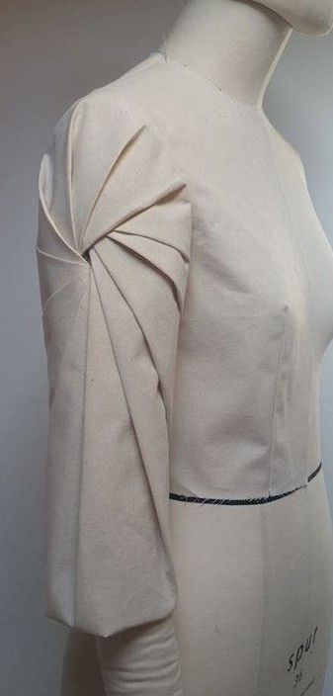](https://s-media-cache-ak0.pinimg.com/originals/fe/9b/20/fe9b208c8330e067fd26f08bca6262ea.jpg)**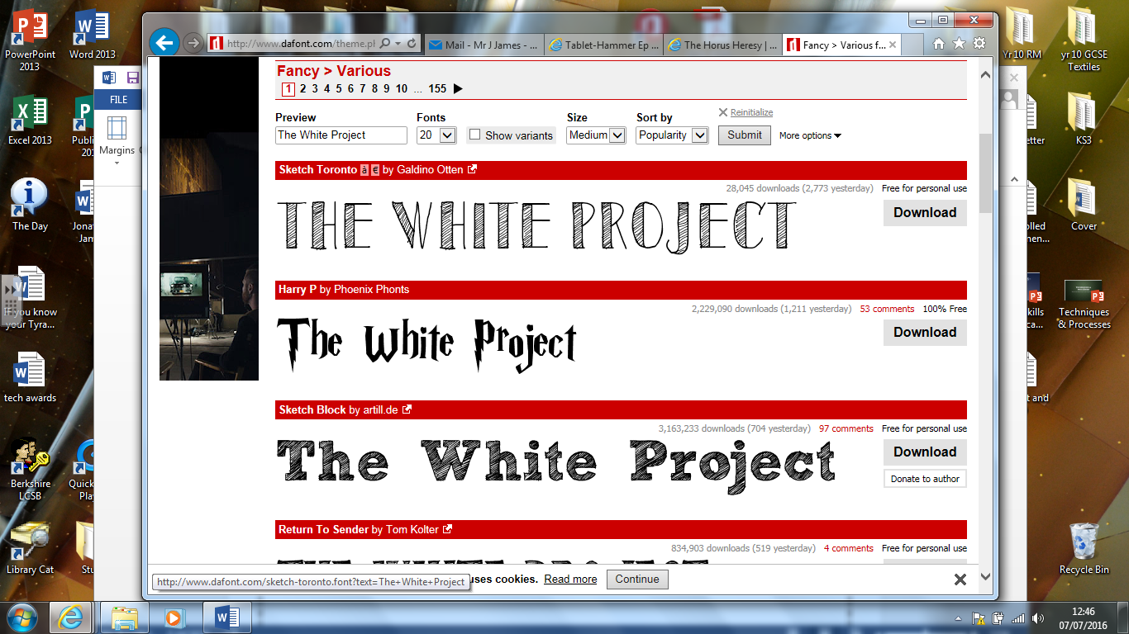

The Deadline for all this work will be **9-9-16** please submit at the Design Technology Office for Mr James by lunch time.

In preparation for this project you need to complete the research based tasks below and bring them to our first lesson.

Task 1: Moodboard

You need to produce an A4 moodboard with a minimum of 20 images on it. The theme of this moodboard is Technical construction. All these images must be devoid of colour so only White, Black and Grey scale. These images should also reflect elements of unusual construction or be inspiration for unusual construction.

Task 2: Case study

You need to pick 3 of the designer from below, and produce a case study on them. The case study should look at the history of the designer and their current work, you also need to find out where they are getting their inspiration from.

Johan Ku Matija Cop Stephane Rolland

Robert Wun Qui Hao Sandra Backlund

Gareth Pugh Tia Cibani Feyrouz Ashoura

Iris Van Herpen Charlotta Mattsson Davis Laporte

Anja Dragan Liu Fang Issey Miyake

In Fashion and Textiles it is important to understand how the construction of a garment can in itself become something beautiful as a decorative technique and help to bring a technical aspect to the garment.

In year 12 you will be doing “The White Project”. You will be experimenting with how to manipulate fabric through pattern development and construction techniques, Bring interest and creativity to a garment without using colour. The work you will be doing over the summer will form the basis for you research for this project.