AS level Transition Work.

**Suggested reading**

The Geographical Magazine is the magazine for the Royal Geographical Society and is published every month. It has lots of interesting articles about newsworthy geographical events. It is available in WH Smiths or you can join online. The Royal Geographical Society web site will also direct you to sources of additional reading.

Follow Geographicalmag on Twitter as well.

Geography review and the National Geographic publish journals with interesting articles on the latest thinking about rivers and rivers management.

**General Textbooks**

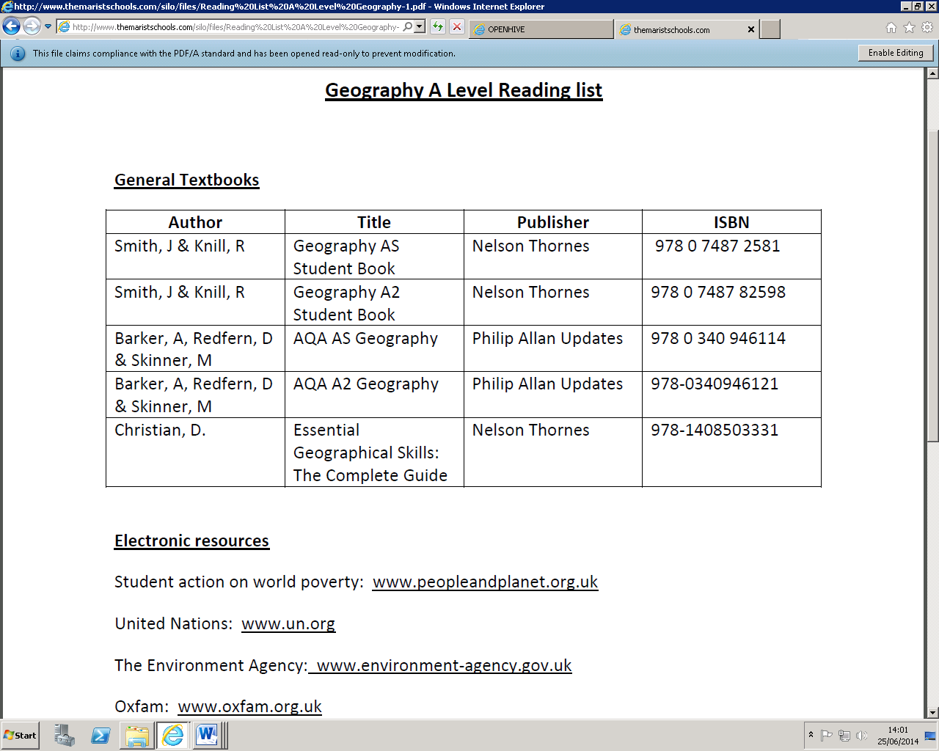

**Wider Reading**

These books will also be of interest to geographers. They will not be assessed but are just a little insight to how Geography affects our reality and our fiction!

Joe Simpson (1998) Touching the Void

Sebastian Junger (2006) The Perfect Storm

Al Gore (2006) An inconvenient Truth

Tim Flannery The Weather Makers

Craig Leland Childs (2002) The Desert Cries

Bill Bryson (1996 )Notes from a small Island

George Orwell (2001 )The road to Wigan Pier

Joe Benett (2010) Hello Dubai; Skiing Sand and Shopping in the World’s Weirdest City

Raymond Barret (2010) Dubai Dreams. In the Kingdom of Bling

Tim Butcher (2008) Blood River

Jonathan Watts (2010) When a billion Chinese jump

Khaled Hosseini (2008 )A Thousand Splendid Suns

John Le Carre The Constant Gardener

Andrea Levy (2009 )Small Island

Maria Lewycka (2006) A Short History of Tractors in the Ukraine

Nicholas Crane(2007) Great British Journeys

Jan Zalasiewicz (2010) The Planet in a Pebble

|  |  |  |  |  |
| --- | --- | --- | --- | --- |
| **AS Transition Work: Geography**  **Coastal Systems and Landscapes** | | | | |
| *Task: Produce a* ***5*** *page guide on the geomorphological processes that shape the coast.*  *You will be using your guide to answer examination questions in class.* | | | | |
| Page 1: What are geomorphological processes?  In no more than 50 words define geomorphological processes and categorise the processes  at play on the coastal landscape. | | | | |
| Page 2: Define the term marine erosion.  Use labelled diagrams to outline the following types of erosion.   * Hydraulic action * Wave quarrying * Corrosion/abrasion * Cavitation * Solution * Attrition   Define the term deposition and outline the conditions necessary for deposition to take place. | | | | |
| Page 3: Define the term transportation.  Use labelled diagrams to outline the following types of transportation.   * Traction * Saltation * Suspension * Longshore/ littoral drift | | | | |
| Page 4: Define the term sub aerial processes.  Distinguish between mechanical, biological and chemical weathering.  Use labelled diagrams and explanations to outline these processes. | | | | |
| Page 5: Define the term mass movement  Use labelled diagrams to outline the following types mass movement at play on the coast.   * Slumping * Soil creep | | | | |
| Suggested resources:  The websites below are recommended for AS students, be careful of using other sites which maybe aimed at GCSE standard.  <http://thebritishgeographer.weebly.com/coastal-processes.html>  <https://geographyas.info/#coasts>  <http://www.alevelgeography.com/coasts/>  <https://aqageography.wordpress.com/coastal-environments/coastal-processes/>  <http://www.geography.learnontheinternet.co.uk/topics/whatiscoastalerosion.html#erosion>  <https://www.geography-fieldwork.org/coast/coastal-processes.aspx>  Don’t forget the geography department and the library, have a wealth of textbooks which can be used to provide you with information too. | | | | |
| Transition work checklist and mark sheet: | | | | |
|  | | [Image result for unhappy emoji](https://www.google.co.uk/imgres?imgurl=http://cliparts.co/cliparts/pT7/rar/pT7rarzjc.png&imgrefurl=http://cliparts.co/clipart/3621803&docid=lp4qob863DnePM&tbnid=RrMA4Xb1-r_LGM:&w=480&h=480&safe=strict&bih=743&biw=1024&ved=0ahUKEwi9waumuqfNAhWJAcAKHQZPB5sQMwgtKA8wDw&iact=mrc&uact=8) | [Related image](https://www.google.co.uk/imgres?imgurl=https://furcoatsnoknickers.files.wordpress.com/2015/04/emoji.jpg&imgrefurl=https://furcoatsnoknickers.com/2015/04/28/the-french-are-more-in-love-and-the-americans-are-more-gay-insights-in-a-time-of-emojis/&docid=kKCbDd5MVB6A_M&tbnid=CTed-Xbt4HADUM:&w=582&h=387&safe=strict&bih=743&biw=1024&ved=0ahUKEwjp3ZPzuafNAhXFI8AKHdrFC4UQxiAIBygF&iact=c&ictx=1) | [Image result for happy emoji](https://www.google.co.uk/imgres?imgurl=http://eat-marketing.co.uk/wp-content/uploads/2015/09/emoji-marketing-1.jpg&imgrefurl=http://eat-marketing.co.uk/emoji-marketing/&docid=LECbMmIQFtDCsM&tbnid=B674FHWu-idxMM:&w=750&h=400&safe=strict&bih=743&biw=1024&ved=0ahUKEwiwwPTsuafNAhUiJcAKHcFaCCkQMwhAKBgwGA&iact=mrc&uact=8) |
| Definition of geomorphological processes | |  |  |  |
| Definition of erosion | |  |  |  |
| Labelled diagrams of erosion types | |  |  |  |
| Deposition definition | |  |  |  |
| Conditions necessary for deposition | |  |  |  |
| Definition of transportation | |  |  |  |
| Labelled diagrams of transportation | |  |  |  |
| Definition of sub aerial processes | |  |  |  |
| Distinguish between weathering types. | |  |  |  |
| Labelled diagrams of weathering | |  |  |  |
| Definition of mass movement | |  |  |  |
| Labelled diagrams of mass movement | |  |  |  |
| Strengths |  | | | |
| Targets |  | | | |
| RWCM |  | | | |
| Self reflection |  | | | |