Yr 12 Language Summer Assignment

Read the following story carefully and then underline the following language features:

* Nouns
* Verbs
* Adjectives
* Adverbs
* Pronouns
* A simple sentence
* A complex sentence

If you are unsure what any of these features are, then you need to research them, because you should be familiar with these concepts before you start the course!

Please bring your annotated copy to your first lesson as we will be using this in our introduction to the course.

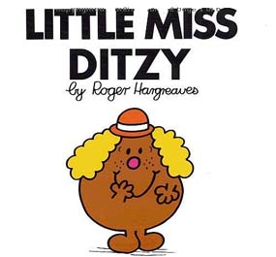

Little Miss Ditzy didn’t set the alarm on her phone because she had a ‘free’ first period. She woke up at 9.45 and by the time she strolled into school she was ten minutes late for Period 2. When Little Miss Ditzy sat down she put her phone on the desk. The miserable old teacher told her to put it away. This was against Little Miss Ditzy’s human rights, so she kept it on her lap in case she received a vital message.

Little Miss Ditzy had unfortunately forgotten to bring all of the notes from last lesson, and the work she had done was on loose paper at the bottom of her bag. When Little Miss Ditzy pulled it out, it was very crumpled and her Coke had leaked over most of it. Poor Little Miss Ditzy.

Little Miss Ditzy kept up this lackadaisical approach to her studies for two years. Little Miss Ditzy massively underachieved and didn’t get any offers from universities. Silly Little Miss Ditzy!