AS PSYCHOLOGY SUMMER WORK

Welcome to AS Psychology! We know you are going to have a fabulous time on this course but before you get started there are 2 essential tasks that you will need to complete…
Task 1:

Read and make notes on the information below in
preparation for starting the course this September. This task will be due in the second lesson back. You will need to do this as neatly as possible as it will really help you understand some of the approaches you will study on the AS course ☺

Introduction to Psychology

- Psychology as an academic subject is relatively new, going back just over 100 years. However, some of the issues and debates it discusses have been around forever. For example, people have always discussed the role of nature (biology) and nurture (environment) in making us who we are.

- The issue raised above further illustrates that fact that psychology is an extremely diverse subject. Psychologists vary in terms of the basic beliefs they have about what makes us behave in the way that we do. These different perspectives/approaches are:

- Biological/physiological
- Behavioural
- Cognitive

Biological/physiological approach

- This approach is interested in looking at what we are made of and the role that biology plays in how we think and feel.

- This approach assumes that we are just like any other animal, only the equipment we have is slightly more sophisticated. The implication being that we act in certain ways because we share similar instincts to non-human animals, which are genetically pre-programmed from birth.

e.g. baby geese are programmed to attach themselves to the first thing they come into contact with

- If patterns of behaviour are genetic it stands to reason that we must have inherited them from our parents. They have been passed on from generation to generation through our genes and DNA.

e.g. physical characteristics, such as eye colour and height are passed down though our genes

- Psychologists who subscribe to this believe that psychological
characteristics like depression and intelligence are passed on in exactly the same way.

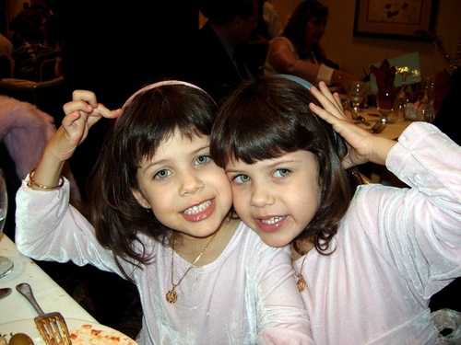
- They would therefore be interested in studying family members to see if there is a genetic link. Twin studies, both identical (MZ) and non-identical (DZ), are also another method that they would find particularly useful, especially if the twins have been reared apart (adoption studies).
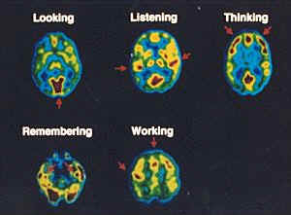
- An essential component we are born with is our brain. Physiological psychologists are interested in the role that different parts of the brain play in our behaviour and experience. This is known as localisation of function.

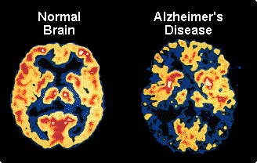
- Brain scanning techniques, such as PET scans and CAT scans show which areas of the brain are active whilst carrying out different psychological tasks. They can also highlight different kinds of brain damage, as shown with the image of a normal patient’s brain compared to that of a patient suffering from Alzheimer’s.

- Our brains are also responsible for the production of specific chemicals that affect how we behave and feel. These are known as neurotransmitters (e.g. dopamine, noradrenaline, and serotonin) because they transmit messages between different nerve cells.

  - It has been suggested that an imbalance of these chemicals could be the cause of certain types of psychological disorders. For example, depression has been linked with low levels of serotonin, whereas schizophrenia has been linked with high levels of dopamine.

  - Drugs that are often prescribed to alleviate such symptoms help because they affect the production of these neurotransmitters.

  - Other chemicals the body makes are hormones. These biochemicals have been claimed to have a major effect on things such as stress and aggression.

  - Evolutionary psychology is another approach that also investigates the role of genes. They claim that certain genes are adaptive because they serve a purpose, specifically in regards to survival. Therefore, those with the best genes are more likely to reproduce.

e.g. more African elephants with the “tuskless gene” are being born because they have fewer predators & are less likely to be shot by poachers

Behavioural approach

Classical conditioning

  - This approach is interested in how we are created by our environment and the way in which we learn.

  - They disagree with the biological approach because they believe that we are born without any pre-programmed patterns of behaviour, rather like a “blank slate” (tabula rasa). From this point of view, everything about us derives from our experiences.

  - Initially, behaviourists were interested in the link between an event in the environment, the behaviour that follows, and how it was established.

e.g. Why does the sound of an ice cream van make your mouth water?

Why do you turn your head when your name is called?

- Behaviourists argue that this happens because the stimulus has been conditioned to a specific response. The association formed between the two is sometimes referred to as S-R (stimulus-response) psychology.


  - In the early 1900’s, a Russian named Ivan Pavlov studied how this process occurred. He noticed how dogs naturally salivated before they were fed. To condition this process, Pavlov rang a bell before the food was given to the dogs. After a while Pavlov was able to just ring the bell and the dogs would salivate even if no food was given to them. This is because they had been conditioned to associate the sound of a bell with food.
This kind of learning is referred to as classical conditioning.

- Watson & Rayner applied this to humans when they conditioned a
young baby boy (“Little Albert”) to become terrified of “furry objects” (e.g. white rabbits, cotton wool), as they associated these objects with a loud noise.
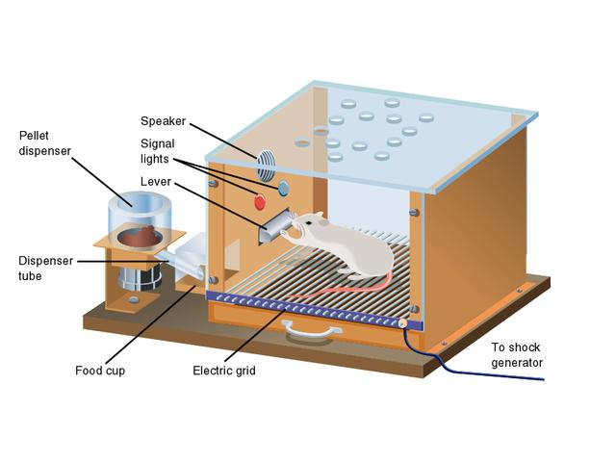
Operant conditioning

- Classical conditioning only appears to work with behaviour that already exists, whereas operant conditioning is able to demonstrate how we learn a completely new behaviour.

- This type of learning was developed by Skinner from experiments conducted on rats, cats and even pigeons. Using Skinner boxes”, he trained non-human animals to perform complex tasks on the basis of rewards (positive reinforcers) and punishments.

- Skinner believed that human beings learn their patterns of behaviour in much the same way.

Social learning theory

- This is a further development from operant conditioning, the only difference being that it recognises how people learn from what happens to others rather than just themselves. This type of learning is also known as ‘observational learning’ and is associated with Albert Bandura.

  - Bandura argued that people imitate and model their behaviour on others if the outcome is positive, whereas they avoid any behaviour observed producing a negative outcome (e.g. punishment). This is referred to as “vicarious reinforcement”.

  - In doing this, Bandura introduced an element of cognition (thinking) into learning by emphasising how people store and remember certain behaviours until they are appropriate.

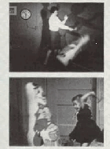
  - Bandura emphasised the importance of role-models in the family, peer group and the mass media.

  - His most famous experiment demonstrated how children imitated role-models if they saw the role models being rewarded for hitting an inflatable doll (“Bobo doll”).

Cognitive approach

- The cognitive approach is concerned with internal mental processes and the role that thoughts and feelings have on our behaviour.

- This approach developed in the 1950’s as a response to the behaviourist view that only focused on observable behaviour.
The cognitive approach believes that we actively think about events and consider their meanings.

- They are especially interested in the mental processes involved in things like perception, attention, memory, language & thinking and problem-solving.

- In order to describe such processes, cognitive psychologists often compare us to computers (computer analogy). They see our minds as being “information processors” that input, store and retrieve data in the same way as computers.

- Cognitive psychologists make use of experiments in order to study the processes involved in how we think and behave.

e.g. The Muller-Lyer illusion is
visual illusion that is used in experiments to investigate
how people perceive information

- They also employ PET scans and CAT scans to highlight the different parts of the brain used when processing information.

- From this perspective, psychological disorders are often explained as the result of faulty thinking or cognitive distortions.

e.g. Anorexics are argued to have a “distorted body image”. This means that they view their body as being much larger than it really is

Schizophrenics are believed to lack the ability to monitor themselves and their own behaviour. As a result, they do not realise that some behaviours are actually their own

- Cognitive therapy (also called cognitive-behavioural therapy or CBT) therefore focuses on changing how a person thinks about themselves and their situation; the idea being that if you change how someone thinks, you change how they behave.

Task 2:

We now want you to apply two of the approaches identified above to explain a specific type of behaviour you find interesting.

Areas of interest could include:

- Why do people diet?
- Why do some people wear “lucky” mascots?
- Why do people get stressed?
- Why do people smoke?
- Why do some people suck their thumbs?
- Why do some people get tattoos?
- Why are some people afraid of flying?
- Why do people give money to charity?

You will be expected to give in this work the second lesson back, and your essay will need to be at least 1 page (A4) long.

Congratulations! You have now completed your summer work so you can relax and enjoy the sunshine ☺ Remember you will need to bring in both tasks for your second lesson of AS Psychology in September.

END OF AS PSYCHOLOGY SUMMER WORK

