What are Dental Care Professionals

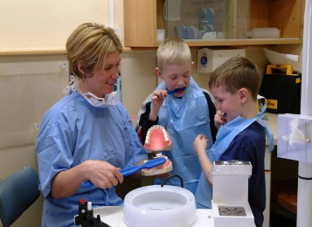
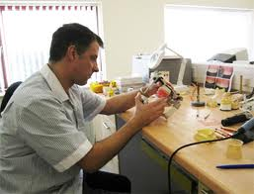

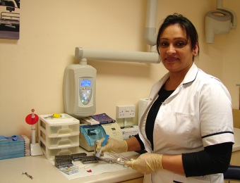

Other careers in Dentistry

Dental Care Professionals are the individuals that make up the wider support team of dentistry and work in a variety of sectors including practice, hospital or even the armed forces. These include Dental Nurses, Dental Technicians, Clinical Dental Technicians, Dental Hygienists, Dental Therapists and Orthodontic Therapists.

An outline of each career and their entry requirements are outlined below.

Dental Nursing
These are traditionally female jobs, but there are a growing number of male nurses training and qualifying as dental nurses. In the last few years, all dental nurses must take the dental nursing examination in order to be able to register with the General Dental Council and work as a nurse. The training is usually done on the job, with academic sessions one evening a week for 6 months. They gain a record of experience in all aspects of dentistry before taking the exam. There are usually no academic qualifications needed to work as a trainee dental nurse, but in order to progress, you will need to study for an approved course in dental nursing. There is often a wide variation in pay for nurses depending on their employer and can range from £11,000-£22,000 for a full time position.

Part-time courses will typically require GCSEs at grade D-G (or equivalent) for entry, although others may require GCSEs at grade A-C (or equivalent) as a minimum. Full-time courses may require evidence of A' level/AS level study. Nurses once qualified can take a number of further courses to enhance their skills and make their jobs more rewarding. They can gain qualification in specialist areas of dentistry such as Sedation, Radiology and Orthodontics. Gaining a qualification as a dental nurse is also the gateway to becoming Hygienists, Therapists and Orthodontic therapists.

For more information look at the website of the British Association of Dental Nursing
(http://badn.org.uk)

Dental Hygienists
In order to be a Hygienist, you have to have worked as a dental nurse as well as gain a qualification in Hygiene, which takes at least 2 years. There are only a few places available a year to train and so this is a very competitive job. Hygienists work under dentists, who diagnose and give a treatment plan for the hygienist to follow.

They are involved in the treatment and management of gum disease and oral health. You will give anaesthetic injections, clean teeth above and below the gums and provide oral hygiene instruction for patients. Hygienists can earn anything up to £50-60,000 per year.

The entry requirements
Five GCSE subjects graded A - C or equivalent, plus two A levels or a recognised dental nursing qualification.

For more information go to the website of the British Society of Dental Hygiene and Therapy (http://www.bsdht.org.uk/profession.html)

Dental Therapist
As with Hygienists, you must be a dental nurse before training to be a therapist. There are only a few places to train for this, but it tends not to be as competitive to get a place. Again working under the direction of a dentists, therapists will carry out minor dental treatments such as small fillings, extraction of baby teeth, temporary crowns to baby teeth and particularly may work in the field of children’s dentistry. They have been trained to identify dental disease but do not make the initial diagnosis and treatment plan. Most seem to work wither in the community dental service or hospital services so the pay scale will be modest but can be up to £35,000.

Entry requirements

Five GCSE subjects graded A - C, plus two A levels or a recognised qualification in dental nursing. You may also be required to have some experience of dental nursing before taking the course.

The training takes between 2-3 years. For more information look at the website of the British Association of Dental Therapists (http://www.badt.org.uk/careers/careers.html)

Orthodontic Therapist
This is a recent career pathway for dental nurses who are interested in orthodontics. Under the guidance and prescription of a dentist or Orthodontist they are able to carry out orthodontic treatment for patients who have been assessed and treatment planned. There are only a limited number of centres that provide this training but most of the experience required in the 1 year course will happen in a regular orthodontic practice. Therapists will be able to earn a salary equivalent to that of a hygienist. Entry Requirements for Orthodontic Therapy are GCSE English, Mathematics and Science at Grade C or above, or equivalent. NVQ Level 3 in Oral Healthcare, or equivalent

Current employment as a dental nurse, dental hygienist, dental therapist or dental technician, and being on the statutory register is also required.
At least one year full-time post-qualification experience, or equivalent.
Dental Technicians
These are skilled individuals who make the dentures, crowns, bridges and dental braces that improve patient’s appearance, speech and their ability to chew. Working to dentists or doctors prescriptions, technicians use a wide range of materials to design and construct appliances to meet each patient’s needs. They must be registered with the General Dental Council which involves qualifying in a registered qualification.
There are four specialist areas. Prosthodontic technicians design and make dentures. Conservation technicians specialise in crown and bridge work. Orthodontic technicians make braces to correct tooth positions. Maxillo-facial technicians (sometimes also known as maxillofacial prosthetists) work is based in hospital oral surgery, ophthalmic, cancer and burns units, helping to reconstruct the faces of patients damaged by accident or disease. Some Technicians are also Clinical Dental technicians.
Clinical dental technicians design, create, construct and modify (including repairing) removable dental appliances for patients. They insure optimal fit, maximum comfort and general well-being of patients. They are qualified and experienced dental technicians who have undertaken additional training in sciences, clinical skills, and interpersonal skills and are able to work independently of other dental team members.
Most technicians will earn an average of £20-40,000 per year.
Qualifications such as the BTEC National Diploma in Dental Technology will require you to have at least four GCSEs at grade C or above or the equivalent, a foundation degree can also be taken (in which case you'll normally need to be employed in a trainee dental technician role) or a BSc (Hons) degree in Dental Technology (for which A' levels or equivalent qualifications are usually required).
Produced by Paula L Buffham BDS, FDSRCS, Mmed Sci, PhD
Park Lane Orthodontics, 65 Park Lane, Tilehurst, Reading, RG31 5DP
Tel: (0118) 9411628 www.parklaneorthodontics.co.uk

