Dear parent/carer, 19th June 2013

**Higher Education Evening**

A special parents’ evening will be held on **Monday 1st July at 7.00pm in the Main Hall**. This is intended specifically to inform parents who have no experience of the current application procedure for Higher Education. This will include information on the different types of university students can apply for, factors to consider when choosing a course/university and how/where to get information about finance. I would be grateful if you could return the reply slip at the bottom of this letter to the sixth form office as soon as possible, or e-mail [cbullion@littleheath.w-berks.sch.uk](mailto:cbullion@littleheath.w-berks.sch.uk)

**PSHE Assembly – 11th July**

All Year 12 students will be off timetable Period 4 on Thursday 11th July to attend a PSHE session about genocide with particular reference to Rwanda which some students may find upsetting. If a parent/carer feels that their child should opt out of this session then please e-mail me at the e-mail address below.

If you would like to discuss any issues or concerns with me at any time please do not hesitate to contact me on the above number, or I can be contacted by e-mail at [rhand@littleheath.w-berks.sch.uk](mailto:rhand@littleheath.w-berks.sch.uk)

Yours sincerely,

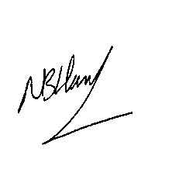

Mr R Hand

Head of Year 12

**HIGHER EDUCATION EVENING – Monday 1st July**

We will*/will not* be able to attend the Higher Education Evening on the above date

*\*Please delete as appropriate*

STUDENT NAME .......................................................................

Signed .......................................................................

Please return to the Sixth Form Office *(thank-you)*