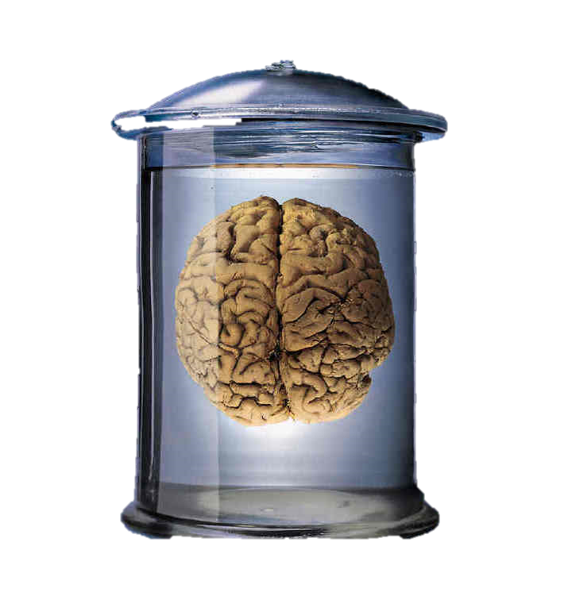
AS Philosophy – Epistemology
Personal Learning Checklist

Student Name:
CLASS:

Subject Name:  AQA Philosophy | Unit Name:  Epistemology
Minimum Target Grade: | Aspirational Target Grade:

Knowledge/Specification | Not Yet | Not Sure | Yes | To address this before the exam I will:-
THEME 1 – PERCEPTION: WHAT ARE THE IMMEDIATE OBJECTS OF PERCEPTION?
Key Concepts:
Direct realism
Indirect realism
Berkeley’s Idealism
1.1 Direct realism: the immediate objects of perception are mind-independent objects and their properties.
Issues with direct realism, including:
- The argument from illusion

- The argument from perceptual variation (Russell's table example)

- The argument from hallucination (the possibility of experiences that are subjectively indistinguishable from veridical perception)

- The time-lag argument.

Knowledge/Specification | Not Yet | Not Sure | Yes | To address this before the exam I will:-
1.2 Indirect realism: the immediate objects of perception are mind-dependent objects that are caused by and represent mind independent objects.
Issues with indirect realism, including:  - It leads to scepticism about the 'existence' of the external world (attacking 'realism')  - Responses to that issue:  - External world is the 'best hypothesis' (Russell);  - Coherence of the various senses and lack of choice over our experiences (Locke)  - It leads to scepticism about the 'nature' of the external world (attacking 'representative')  - Responses to that issue:  - Sense data tell us of 'relations' between objects (Russell;  - The distinction between primary and secondary qualities (Locke)  - Problems arising from the view that mind-dependent objects represent mind-independent objects and are caused by mind-independent objects. | -
Knowledge/Specification | Not Yet | Not Sure | Yes | To address this before the exam I will:-
1.3 3. Berkeley’s idealism: the immediate objects of perception (ie ordinary objects such as tables, chairs, etc) are mind-dependent objects.
Berkeley’s attack on the primary/secondary property distinction and his ‘master’ argument.

Issues with Berkeley’s idealism, including:

- It leads to solipsism

- It does not give an adequate account of illusions and hallucinations

- It cannot secure objective space and time

- Whether God can be used to play the role He does.

THEME 2 – THE DEFINITION OF KNOWLEDGE: WHAT IS PROPOSITIONAL KNOWLEDGE?
Key Concepts:
Acquaintance knowledge – ‘knowing of’
Ability knowledge – ‘knowing how’
Propositional knowledge – ‘knowing that’
Tripartite definition of knowledge

2.1 Distinction between: acquaintance knowledge, ability knowledge and propositional knowledge (knowing ‘of’, knowing ‘how’ and knowing ‘that’).
2.2 The tripartite view: justified true belief is necessary and sufficient for propositional knowledge (S knows that p only if S is justified in believing that p, p is true and S believes that p) (necessary and sufficient conditions).
Knowledge/Specification | Not Yet | Not Sure | Yes | To address this before the exam I will:-
Issues with the tripartite view:  - The conditions are not individually necessary:  - Justification is not a necessary condition of knowledge  - Truth is not a necessary condition of knowledge  - Belief is not a necessary condition of knowledge.  - Cases of lucky true beliefs show that the justification condition should be either strengthened, added to or replaced (ie Gettier-style problems).  - Responses to issues with the tripartite view, including:  - Strengthen the justification condition: Infallibilism and the requirement for an impossibility of doubt (Descartes)  - Add a 'no false lemmas' condition (J+T+B+N)  - Replace 'justified' with 'reliably formed' (R+T+B) (reliabilism)  - Replace 'justified' with an account of epistemic virtue (V+T+B). | -

Knowledge/Specification | Not Yet | Not Sure | Yes | To address this before the exam I will:-
THEME 3 – THE ORIGIN OF CONCEPTS AND THE NATURE OF KNOWLEDGE: WHERE DO IDEAS/CONCEPTS AND KNOWLEDGE COME FROM?
Key Concepts:
Concept empiricism
Knowledge empiricism
Rationalism
Innatism

3.1 Concept empiricism: all concepts are derived from experience (tabula rasa, impressions and ideas, simple and complex concepts).
Issues with concept empiricism, including:

- Concept innatism (rationalism): there are at least some innate concepts (Descartes’ ‘trademark’ argument, and other proposed examples such as universals, causation, infinity, numbers, etc.)

- Concept empiricist arguments against concept innatism:

- Alternative explanations (no such concept or concept re-defined as based on experiences)

- Locke’s arguments against innatism;

- Its reliance on the non-natural.

Knowledge/Specification | Not Yet | Not Sure | Yes | To address this before the exam I will:-
3.2 Knowledge empiricism: all synthetic knowledge is a posteriori (Hume’s ‘fork’); all a priori knowledge is (merely) analytic.
Issues with knowledge empiricism, including:  - Knowledge innatism (rationalism): there is at least some innate a priori knowledge (arguments from Plato and Leibniz)  - Knowledge empiricist arguments against knowledge innatism:  - alternative explanations (no such knowledge, in fact based on experiences or merely analytic);  - Locke’s arguments against innatism;  - its reliance on the non-natural  - Intuition and deduction thesis (rationalism): we can gain synthetic a priori knowledge through intuition and deduction (Descartes on the existence of self, God and the external world)  - Knowledge empiricist arguments against intuition and deduction:  - the failure of the deductions or the analytically true (tautological) nature of the conclusions  - Arguments against knowledge empiricism: the limits of empirical knowledge (Descartes’ sceptical arguments). | -

REVISION
Use the information on this checklist to make revision cards and notes
Grade tracking:

Grade | Date | Grade | Date | Grade | Date

Grade | Date | Grade | Date | Grade | Date

Note: You should discuss this checklist regularly with your subject teacher/mentor

